NOTICE OF FY 2018/2019 BUDGET MEETINGS
THE MERCER COUNTY COMMISSION WILL MEET ON THE FOLLOWING DATES AND TIMES TO RECEIVE FY 2018/2019 BUDGET REQUESTS FROM COUNTY OFFICIALS:
THURSDAY, MARCH 8, 2018
9:00 A.M. CIRCUIT CLERK
9:30 A.M. PROSECUTING ATTORNEY
10:00 A.M. COUNTY COMMISSION
10:30 A.M. COUNTY CLERK
11:00 A.M. EMERGENCY MGT/FLOOD CONTROL
11:30 A.M. ASSESSOR
12:00 P.M. GLENWOOD PARK
1:30 P.M. WVU EXTENSION SERVICE
2:00 P.M. HEALTH DEPARTMENT

FRIDAY, MARCH 9, 2018
2:00 P.M. SHERIFF

MONDAY, MARCH 12, 2018
9:00 A.M. BUDGET REVIEW

GENE BUCKNER, PRESIDENT
MERCER COUNTY COMMISSION

Let the record show that Gene Buckner, Commissioner, Greg Puckett, Commissioner, Bill Archer, Commissioner, Verlin Moye, County Clerk, Vicky Reed, County Administrator, Jessica Dixon and Roger Topping were present. Jamie Null was present on Thursday, March 8th.

COMMISSION MEETING – TUESDAY, MARCH 13, 2018 –10:00 A.M.

AGENDA: OPEN WITH PRAYER (Pastor Connie Lester)

PLEDGE OF ALLEGIANCE
MINUTES OF PREVIOUS MEETING

RECOGNITION - Resolution Honoring Hazel Dickens
Old-Time Mountain Music Singer/
Songwriter-Born in Mercer County

APPOINTMENTS/REAPPOINTMENTS
OATHS OF OFFICE - Mercer County Prosecutor’s Office
Tara Pack-Victims Advocate
Misty Chambers-Victims Advocate
Meku Leftwich-Legal Secretary

- Mercer County Maintenance Department
Linnea Sanders-Part-Time Custodian

- Mercer County Assessor’s Office
Kim Overton Allen-Deputy Clerk

- Mercer Day Report Center
Mark Anthony Mooney
PT Community Service Officer

- Mercer County Sheriff’s Department
John Howell, Bailiff
Montoya Kemp, Process Server
CONTRACTS AND
RESOLUTIONS - First Public Reading-Amended Exotic
Entertainment Ordinance
Greg Puckett, Commissioner

- First Public Reading
Groundwater Restriction for
418 ½ New Hope Road, Princeton, WV

- E.L. Robinson Engineering Agreement
Route 19 Water Project
Ray Tilley, P.E.

- Region I Planning & Development Council
HUD Citizen Participation Plan
Jason Roberts, Executive Director

- Region I Planning & Development Council
Annual Project Prioritization
Jason Roberts, Executive Director

- Lewis Glasser PLLC
Engagement Letter for Collection of
Outstanding Personal Property Taxes
Ann Starcher, Attorney

- Hotel/Motel Delinquent Taxes
Letters to Owners of Microtel,
Holiday Inn Express, Days Inn
Tommy Bailey, Sheriff

- Budget Revisions FY 2017/2018
Coal Severance #3
Verlin Moye, County Clerk

ESTATES - Dorothy Collins

- Ellen Thornhill Lambert

FUNDING REQUEST - WV Homeland Security Grant ($5,000)
Tim Farley, Emergency Mgt. Director

- Camp Creek State Park
Timbersports/Ramp Feast
Frank Ratcliffe, Park Superintendent

- Mud Pit Trail Cleanup April 7, 2018
Donna Lowe, Owner

- Town of Bramwell
Coal Mining Heritage Festival
Louise Stoker, Mayor

- National Coal Heritage Area Authority
Bramwell Depot Interpretive Center
Christy Bailey, Executive Director

- Project Graduation
Bluefield High School
Montcalm High School
Pikeview High School
Princeton High School

- Mercer County Sheriff’s Department
Dominion Systems, LLC ($1,070)
Veeam Backup Software Renewal

- Town of Matoaka Water & Sewer
Contracted Services Invoices
George Branton $1,000
Roy Gerwig $1,000

DISCUSSION - Southeast WV Chapter Red Cross
Red Cross Month-March 2018
Courtney Clark, Executive Director

- Domestic Violence Shelter
Amy Burnett

- Global Science Technology
Andrew Parker, Sr. Network Engineer

- Keep Mercer Clean Campaign
Monofilament Fishing Line
Recycling Receptacles
Joshua Parks, Litter Control Officer

- Mercer County Solid Waste Authority
Tire Shredder for Landfill
Eli Testerman, Manager

- Chamber of Commerce Merger Update
Josh Cline, GBCC President & CEO

- Complete Systems Support, Inc.
Online Tax Payment Status Report
Ian Mackie, Lead Developer

- 2018 Heritage Art Contest Update
Bill Archer, Commissioner

- King Coal Highway Update
Greg Puckett, Commissioner

- Glenwood Recreation Park
Update-Greg Pruett, Superintendent
- Town of Matoaka-Update
Bill Archer, Commissioner

- Mercer County 181st Birthday Celebration
Bill Archer, Commissioner

- Bluestone River Water Trail
Update on Public Hearings
Bill Archer, Commissioner

PUBLIC COMMENTS

EXECUTIVE SESSION

COMMISSION TO APPROVE THE FOLLOWING:
1. Invoices
2. Settlements
3. Exonerations
4. List of Approved Estates for February 2018

WEST VIRGINIA:
At a regular session of the County Commission, held for the County of Mercer, at the Courthouse thereof, on Tuesday, March 13, 2018,
Present: Gene Buckner, President
Present: Greg Puckett, Commissioner
Present: Bill Archer, Commissioner

RE: RESOLUTION HONORING HAZEL DICKENS
This day the County Commission honored Hazel Dickens, Old-Time Mountain Music Singer/Songwriter-Born in Mercer County.
HAZEL DICKENS
MERCER COUNTY’S FIRST LADY OF SONG

Whereas, in observance of March as National Women’s History Month, the Mercer County Commission would like to recognize an individual who grew up in most humble circumstances and gained national and international fame for her efforts to give voice to the speechless, sight to the unseen and faces to the faceless working women and men of the world … the late Hazel Dickens; and

Whereas, Hazel Dickens was born in Montcalm on June 1, 1925, as the eighth child of Sarah (Simkins) Dickens and Pastor H. N. Dickens, a Primitive Baptist Church minister and logging truck driver. Even with all of the Dickens working, the family still struggled just to have anything more than the bare necessities. When she was only 16, Hazel along with her parents and some of her siblings moved to Baltimore, Maryland to be close to one of her brothers who was there being treated for tuberculosis; and

Whereas, Hazel worked at several jobs including waitress, store clerk, factory worker and other jobs, while spending her evenings playing double-bass for hillbilly and bluegrass bands in Baltimore and writing songs based on her memories of growing up in the mountains of southern West Virginia. Eventually, she moved to Washington, D.C., and formed a musical partnership with Alice Gerrard; and

Whereas, Hazel drew upon the Primitive Baptist musical tradition to develop her unique vocal style. Although slight in physical stature. Hazel sang with an unamplified voice that was strong, loud and powerful enough to keep the faithful seated in rear pews wide awake. At the same time, the themes of the songs she authored told of the plight of working men and women, the tragedy of poverty, the strength of family love and the power of faith; and

Whereas, in a performing career that spanned nine decades from 1936 to her final performance on March 16, 2011, Hazel put her heart into her music and maintained her steadfast love for her West Virginia roots. Hazel had a profound influence of other female vocalists including Alison Krauss, Emmylou Harris and the Judds. She also carried the story of the plight of coal miners through four songs in the soundtrack of the 1976 Academy Award winning documentary, “Harlan County USA.” and sang “Beautiful Hills of Galilee” in a powerful graveyard scene in the 1987 movie, Matewan; and

Whereas, Hazel Dickens traveled to venues around the world where she performed to great acclaim and following her passing on April 22, 2011 at the age of 85, her family brought her back home to Mercer County and her final resting place at Roselawn Cemetery.

Now, Therefore, Be It Resolved that the Mercer County Commission is proud to recognize Hazel Dickens’ life of dedicated service to her family, her state and her Mercer County home. The Commission also urges citizens to learn more about Mercer County’s First Lady of Song during Women’s History Month.

Dated this 13th day of March, 2018.

MERCER COUNTY COMMISSION: /s/ Gene Buckner_______________________
Gene Buckner, President

/s/ Greg Puckett________________________
Greg Puckett, Commissioner

/s/ Bill Archer_________________________
Bill Archer, Commissioner

RE: OATH – MERCER COUNTY PROSECUTOR’S OFFICE
This day on motion of Greg Puckett, Commissioner, seconded by Bill Archer, Commissioner, the Commission voted unanimously to approve the Employment and Oath of Office for Tara Pack to serve as Victims Advocate for the Prosecuting Attorney’s Office.

RE: OATH – MERCER COUNTY PROSECUTOR’S OFFICE
This day on motion of Greg Puckett, Commissioner, seconded by Bill Archer, Commissioner, the Commission voted unanimously to approve the Employment and Oath of Office for Misty Chambers to serve as Victims Advocate for the Prosecuting Attorney’s Office.

RE: OATH – MERCER COUNTY PROSECUTOR’S OFFICE
This day on motion of Greg Puckett, Commissioner, seconded by Bill Archer, Commissioner, the Commission voted unanimously to approve the Employment and Oath of Office for Miku Leftwich to serve as Legal Secretary for the Prosecuting Attorney’s Office.

RE: OATH – MERCER COUNTY MAINTENANCE DEPARTMENT
This day on motion of Bill Archer, Commissioner, seconded by Greg Puckett, Commissioner, the Commission voted unanimously to approve the Employment and Oath of Office for Linnea Sanders to serve as Part-Time Custodian for the Maintenance Department.

RE: OATH – MERCER COUNTY ASSESSOR’S OFFICE
This day on motion of Greg Puckett, Commissioner, seconded by Bill Archer, Commissioner, the Commission voted unanimously to approve the Employment and Oath of Office for Kimberly Overton-Allen to serve as Deputy Clerk for the Assessor’s Office.

RE: OATH – MERCER DAY REPORT CENTER
This day on motion of Bill Archer, Commissioner, seconded by Greg Puckett, Commissioner, the Commission voted unanimously to approve the Employment and Oath of Office for Mark Anthony Mooney to serve as Part-Time Community Service Officer for the Day Report Center.

RE: OATH – MERCER COUNTY SHERIFF’S DEPARTMENT
This day the Commission tabled the Employment and Oath of Office for John Howell to serve as Bailiff for the Sheriff’s Department.

RE: OATH – MERCER COUNTY SHERIFF’S DEPARTMENT
This day on motion of Greg Puckett, Commissioner, seconded by Bill Archer, Commissioner, the Commission voted unanimously to approve the Employment and Oath of Office for Montoya Kemp to serve as Process Server for the Sheriff’s Department.

RE: AMERICAN RED CROSS
This day Courtney Clark, Executive Director of the American Red Cross for Southeast West Virginia appeared before the County Commission to give an update from the Red Cross.

RE: PUBLIC READING – GROUNDWATER RESTRICTION-418 ½ NEW HOPE ROAD
This day the County Commission conducted the First Public Reading of a proposed Groundwater Restriction for the Southwest Corner of 418 ½ New Hope Road, East River District, in Princeton, West Virginia.

RE: AGREEMENT – ROUTE 19 WATER PROJECT
This day on motion of Bill Archer, Commissioner, seconded by Greg Puckett, Commissioner, the Commission voted unanimously to approve the Agreement with E. L. Robinson Engineering Co. and the Mercer County Commission for the Route 19 Water Study.

RE: RESOLUTION – REGION I PLANNING & DEVELOPMENT COUNCIL
This day on motion of Greg Puckett, Commissioner, seconded by Bill Archer, Commissioner, the Commission voted unanimously to accept the Region I Planning & Development Council HUD Community Development Block Grant (CDBG)-Citizen Participation Plan.

RE: RESOLUTION – REGION I 2018 ANNUAL PROJECT PRIORITIZATION LIST
This day on motion of Greg Puckett, Commissioner, seconded by Bill Archer, Commissioner, the Commission voted unanimously to approve the Region I Planning & Development Council 2018 Annual Project Prioritization list as follows: 1. Mary’s Branch/Matoaka/Weyanoke Water Extension 2. Coaldale Mountain Sewer Project 3. Route 19-Nubbins/Stovall Ridge Flat Top/Camp Creek/Dunns Water Extension 4. Browning Lambert Mountain Water 5. Oakvale Road Miscellaneous Sewer Extensions 6. Bluewell Water Distribution System Upgrade 7. Bramwell to Buckeye Hollow Water Project 8. Airport Road Water & Sewer Project 9. I-73/74 King Coal Highway 10. Bluestone River Trail Rails to Trails

RE: CONTRACT – LEWIS GLASSER PLLC
This day on motion of Bill Archer, Commissioner, seconded by Greg Puckett, Commissioner, the Commission voted unanimously to approve the Contract with Lewis Glasser PLLC for the collection of outstanding personal property taxes.

RE: HOTEL/MOTEL DELINQUENT TAXES
This day on motion of Bill Archer, Commissioner, seconded by Greg Puckett, Commissioner, the Commission voted unanimously to approve the letters to recover the Hotel Motel Delinquent taxes to the owners of Microtel, Holiday Inn Express and Days Inn.

RE: APPROVAL – COAL SEVERANCE BUDGET REVISION
This day on motion of Greg Puckett, Commissioner, seconded by Bill Archer, Commissioner, the Commission voted unanimously to approve Budget Revision No. 3 for FY 2017/2018 in the amount of $12,300 for the Coal Severance Fund.

RE: ESTATE – DOROTHY COLLINS – DECEASED

BEFORE THE COUNTY COMMISSION OF MERCER COUNTY, WEST VIRGINIA
IN RE: DOROTHY COLLINS, DECEASED.

O-R-D-E-R
On the 13th day of March, 2018, before the Mercer County Commission, came the matter of the Estate of Dorothy B. Collins, upon motion of Henry J. Collins, Jr. and Mark S. Collins, requesting that a copy of the Last Will and Testament of Dorothy B. Collins be accepted for probate.
After discussion and review of this matter by the Commission, upon proper motion and second, and it appearing proper to do so, the Commission ORDERS that the copy of the Last Will and Testament of Dorothy B. Collins, deceased, be accepted for recordation.
All of which was accordingly ADJUDGED and ORDERED. The Clerk of this Commission is DIRECTED to take whatever actions he deems necessary to effectuate this Order.
Dated this the 13th day of March, 2018.
ENTER:
/s/A. Gene Buckner_________________
- GENE BUCKNER, PRESIDENT
MERCER COUNTY COMMISSION

ATTEST:

/s/Verlin T. Moye_______________
VERLIN T. MOYE, CLERK
MERCER COUNTY COMMISSION

RE: ESTATE – ELLEN THORNHILL LAMBERT – DECEASED

BEFORE THE COUNTY COMMISSION OF MERCER COUNTY, WEST VIRGINIA
IN RE: ELLEN THORNHILL LAMBERT, DECEASED.

O-R-D-E-R
On the 13th day of March, 2018, before the Mercer County Commission, came the matter of the Estate of Ellen Thornhill Lambert, upon motion of Iva Fridely, Executrix, requesting that the Sheriff of Mercer County, T.A. Bailey be appointed Administrator CTA of the estate of Ellen Thornhill Lambert, deceased, due to the distance required to travel and upon advice of legal counsel.
After discussion and review of this matter by the Commission, upon proper motion and second, and it appearing proper to do so, the Commission ORDERS that Sheriff of Mercer County, T. A. Bailey be appointed as Administrator CTA of the estate of Ellen Thornhill Lambert, deceased, and Iva Fridely shall be relieved of her duties as Executrix of the estate.
All of which was accordingly ADJUDGED and ORDERED. The Clerk of this Commission is DIRECTED to take whatever actions he deems necessary to effectuate this Order.
Dated this the 13th March, 2018.
ENTER:
/s/A. Gene Buckner_________________
- GENE BUCKNER, PRESIDENT
MERCER COUNTY COMMISSION

ATTEST:

/s/Verlin T. Moye_______________
VERLIN T. MOYE, CLERK
MERCER COUNTY COMMISSION

RE: GRANT – WV HOMELAND SECURITY GRANT PROGRAM
This day on motion of Greg Puckett, Commissioner, seconded by Bill Archer, Commissioner, the Commission voted unanimously to approve funding of reimbursement expenses in the amount of $5,000 from the Video Lottery Fund for the WV Homeland Security Grant.

RE: FUNDING REQUEST – CAMP CREEK STATE PARK AND FOREST
This day on motion of Greg Puckett, Commissioner, seconded by Bill Archer, Commissioner, the Commission voted unanimously to approve a funding request from Frank Ratcliffe, Park Superintendent, Camp Creek State Park and Forest. Funding in the amount of $2,500 will be taken from the Hotel Motel Fund for the Timbersports Competition & Ramp Feast.

RE: FUNDING REQUEST – MUD PIT TRAIL CLEANUP APRIL 7, 2018
This day on motion of Bill Archer, Commissioner, seconded by Greg Puckett, Commissioner, the Commission voted unanimously to approve a funding request from Donna Lowe, Mud Pit Owner. Funding not to exceed $1,000 will be taken from the Hotel Motel Fund for the Trail Cleanup on April 7, 2018.

RE: FUNDING REQUEST – TOWN OF BRAMWELL
This day on motion of Bill Archer, Commissioner, seconded by Greg Puckett, Commissioner, the Commission voted unanimously to approve a funding request from Louise Stoker, Mayor, Town of Bramwell. Funding in the amount of $3,000 will be taken from the Hotel Motel Fund for the Coal Mining Heritage Festival.

RE: FUNDING REQUEST – NATIONAL COAL HERITAGE AREA AUTHORITY
This day the Commission tabled a funding request from Christy Bailey, Executive Director, National Coal Heritage Area Authority to help fund the Bramwell Train Depot Visitor Center.

RE: FUNDING REQUEST – BLUEFIELD HIGH SCHOOL PROJECT GRADUATION
This day on motion of Bill Archer, Commissioner, seconded by Greg Puckett, Commissioner, the Commission voted unanimously to approve a funding request from Bluefield High School. Funding in the amount of $500 will be taken from the Video Lottery Fund for 2018 Project Graduation.

RE: FUNDING REQUEST – PIKEVIEW HIGH SCHOOL PROJECT GRADUATION
This day on motion of Greg Puckett, Commissioner, seconded by Bill Archer, Commissioner, the Commission voted unanimously to approve a funding request from PikeView High School. Funding in the amount of $500 will be taken from the Video Lottery Fund for 2018 Project Graduation.

RE: FUNDING REQUEST – MONTCALM HIGH SCHOOL PROJECT GRADUATION
This day the Commission tabled a funding request from Montcalm High School for 2018 Project Graduation.

RE: FUNDING REQUEST – PRINCETON SENIOR HIGH SCHOOL PROJECT GRADUATION

This day the Commission tabled a funding request from Princeton Senior High School for 2018 Project Graduation.

RE: FUNDING REQUEST – MERCER COUNTY SHERIFF’S DEPARTMENT
This day on motion of Greg Puckett, Commissioner, seconded by Bill Archer, Commissioner, the Commission voted unanimously to approve a funding request for Veeam Backup Software for the Sheriff’s Department from Dominion Systems. Funding in the amount of $1,070 will be taken from the Courthouse Equipment Fund.

RE: FUNDING REQUEST – TOWN OF MATOAKA
This day on motion of Bill Archer, Commissioner, seconded by Greg Puckett, Commissioner, the Commission voted unanimously to approve the water and sewer contracted services invoices for the Town of Matoaka. Funding in the amount of $2,000 will be taken from the Coal Reallocation Fund.

RE: DISCUSSION – DOMESTIC VIOLENCE SHELTER

This day Connie Saunders appeared before the County Commission to discuss the need for a Domestic Violence Shelter in Mercer County.

RE: DISCUSSION – GLOBAL SCIENCE TECHNOLOGY

This day Andrew Parker, Sr. Network Engineer for Global Science and Technology appeared before the County Commission to present a Security and Network Management Service contract and discuss bandwidth upgrades for the Courthouse.

RE: DISCUSSION – KEEP MERCER CLEAN CAMPAIGN

This day Joshua Parks, Litter Control Officer appeared before the County Commission to discuss monofilament fishing line recycling receptacles being placed in Glenwood Park as part of the Keep Mercer Clean Campaign.

RE: DISCUSSION – MERCER COUNTY SOLID WASTE AUTHORITY

This day discussion of a tire shredder for the Mercer County Solid Waste Authority was tabled.

RE: UPDATE – CHAMBER OF COMMERCE MERGER

This day Josh Cline, President & CEO of the Greater Bluefield Chamber of Commerce appeared before the County Commission to give an update on the merging of the Greater Bluefield and Princeton-Mercer County Chambers.

RE: DISCUSSION – COMPLETE SYSTEMS SUPPORT, INC.

This day on motion of Gene Buckner, Commissioner, seconded by Bill Archer, Commissioner, the Commission voted unanimously to table the discussion of the online tax payment system.

RE: UPDATE – 2018 HERITAGE ART CONTEST

This day Bill Archer, Commissioner gave an update on the 2018 Heritage Art Contest which will be held during the Mercer County Fair on August 3 & 4, 2018 at PikeView High School. The winner’s exhibits will be displayed at the Courthouse.

RE: UPDATE – GLENWOOD RECREATION PARK
This day Greg Pruett, Superintendent appeared before the County Commission to present an update on Glenwood Recreation Park. He gathered quotes for various park improvement projects. The park board recommends replacing 3 shelters, adding 2 new shelters, renovating restrooms and miniature golf course.

RE: UPDATE – KING COAL HIGHWAY

This day Greg Puckett, Commissioner gave an update on King Coal Highway.

RE: FIRST READING – EXOTIC ENTERTAINMENT ORDINANCE
This day on motion of Greg Puckett, Commissioner, seconded by Bill Archer, Commissioner, the Commission voted unanimously to table the First Reading of Amended Exotic Entertainment Ordinance.
RE: UPDATE – TOWN OF MATOAKA

This day Bill Archer, Commissioner gave an update on the Town of Matoaka.

RE: MERCER COUNTY 181ST BIRTHDAY CELEBRATION
A Courthouse Luncheon will be held for Employees Honoring Mercer County’s Birthday on Friday, March 16, 2018 from 11:00 a.m. to 2:00 p.m. in Judge Swope’s Courtroom.

RE: DISCUSSION – BLUESTONE RIVER WATER TRAIL
This day Bill Archer, Commissioner gave an update on the public hearings that were held regarding the Bluestone River Water Trail Initiative. The new name is Bluestone Adventure Trail System Non-Motorized.

RE: PUBLIC COMMENTS – LOUISE STOKER
This day Louise Stoker, Mayor, Town of Bramwell appeared before the County Commissioner to discuss the dams. The town is working with the DEP to bring them in compliance. She will keep the Commission updated on the progress.

RE: EXECUTIVE SESSION
This day on motion of Bill Archer, Commissioner, seconded by Greg Puckett, Commissioner, the Commission voted unanimously to go into executive session. On motion of Bill Archer, Commissioner, seconded by Greg Puckett, Commissioner, the Commission voted unanimously to come out of executive session and go back into regular session. No votes were taken during the executive session.

PETITION FOR CANCELLATION OF ERRONEOUS CHARGES
DATE 2/6/2018
Tax Year 2017
Princeton District

TICKET # NAME REASON AMOUNT
712663 Richard Delp Paid taxes on camper in VA. $ 651.18

Tax Year 2017
East River District

TICKET # NAME REASON AMOUNT 710008 Sandra L. Smith Double assessed on MH. $ 64.18

This day the flowing accounts were presented against the County of Mercer, and the Commission having examined each and all of them, doth allow payment from the different accounts, check numbers listed below:

GENERAL COUNTY - Check #69595-69693
COAL SEVERANCE - Check #3557-3559
JUSTICE FINES - Check #5318
MAGISTRATE COURT - Check #5358
HOME CONFINEMENT - Check #2333-2340
HOTEL MOTEL - Check #3671-3686 Void #3677
K-9 FUND - Check #1489-1490
COURTHOUSE EQUIPMENT - Check #744-745
COURTHOUSE ANNEX - Check #1484-1488
VIDEO LOTTERY - Check #1273-1277
COAL REALLOCATION - Check #1008-1009
MCDRC FEES - Check #4689-4705
ASSESSOR REAPPRAISAL - Check #6043-6056
DRUG FORFEITURE - Check #199-201
SHERIFF DRUG FUND - Check #1053
TEEN COURT - Check #203
RECYCLING GRANT - Check #1021-1022
ANIMAL SHELTER EST. DONATION - Check #1011
DEPUTY SHERIFF RETIREMENT - Check #253

It is ordered that this Commission be and is hereby adjourned until Tuesday, April 10, 2018.
_____________________________________PRESIDENT

WEST VIRGINIA:
At a special session of the County Commission, held for the County of Mercer, at the Courthouse thereof, on Thursday, March 22, 2018.
Present: Gene Buckner, President
Present (by phone): Greg Puckett, Commissioner
Present: Bill Archer, Commissioner

NOTICE OF BUDGET MEETING
ON THURSDAY, MARCH 22 2018 AT 9:00 A.M., THE MERCER COUNTY COMMISSION WILL MEET IN THE COMMISSION COURTROOM TO DISCUSS THE BUDGET FOR FY 2018/2019.

GENE BUCKNER, PRESIDENT
MERCER COUNTY COMMISSION

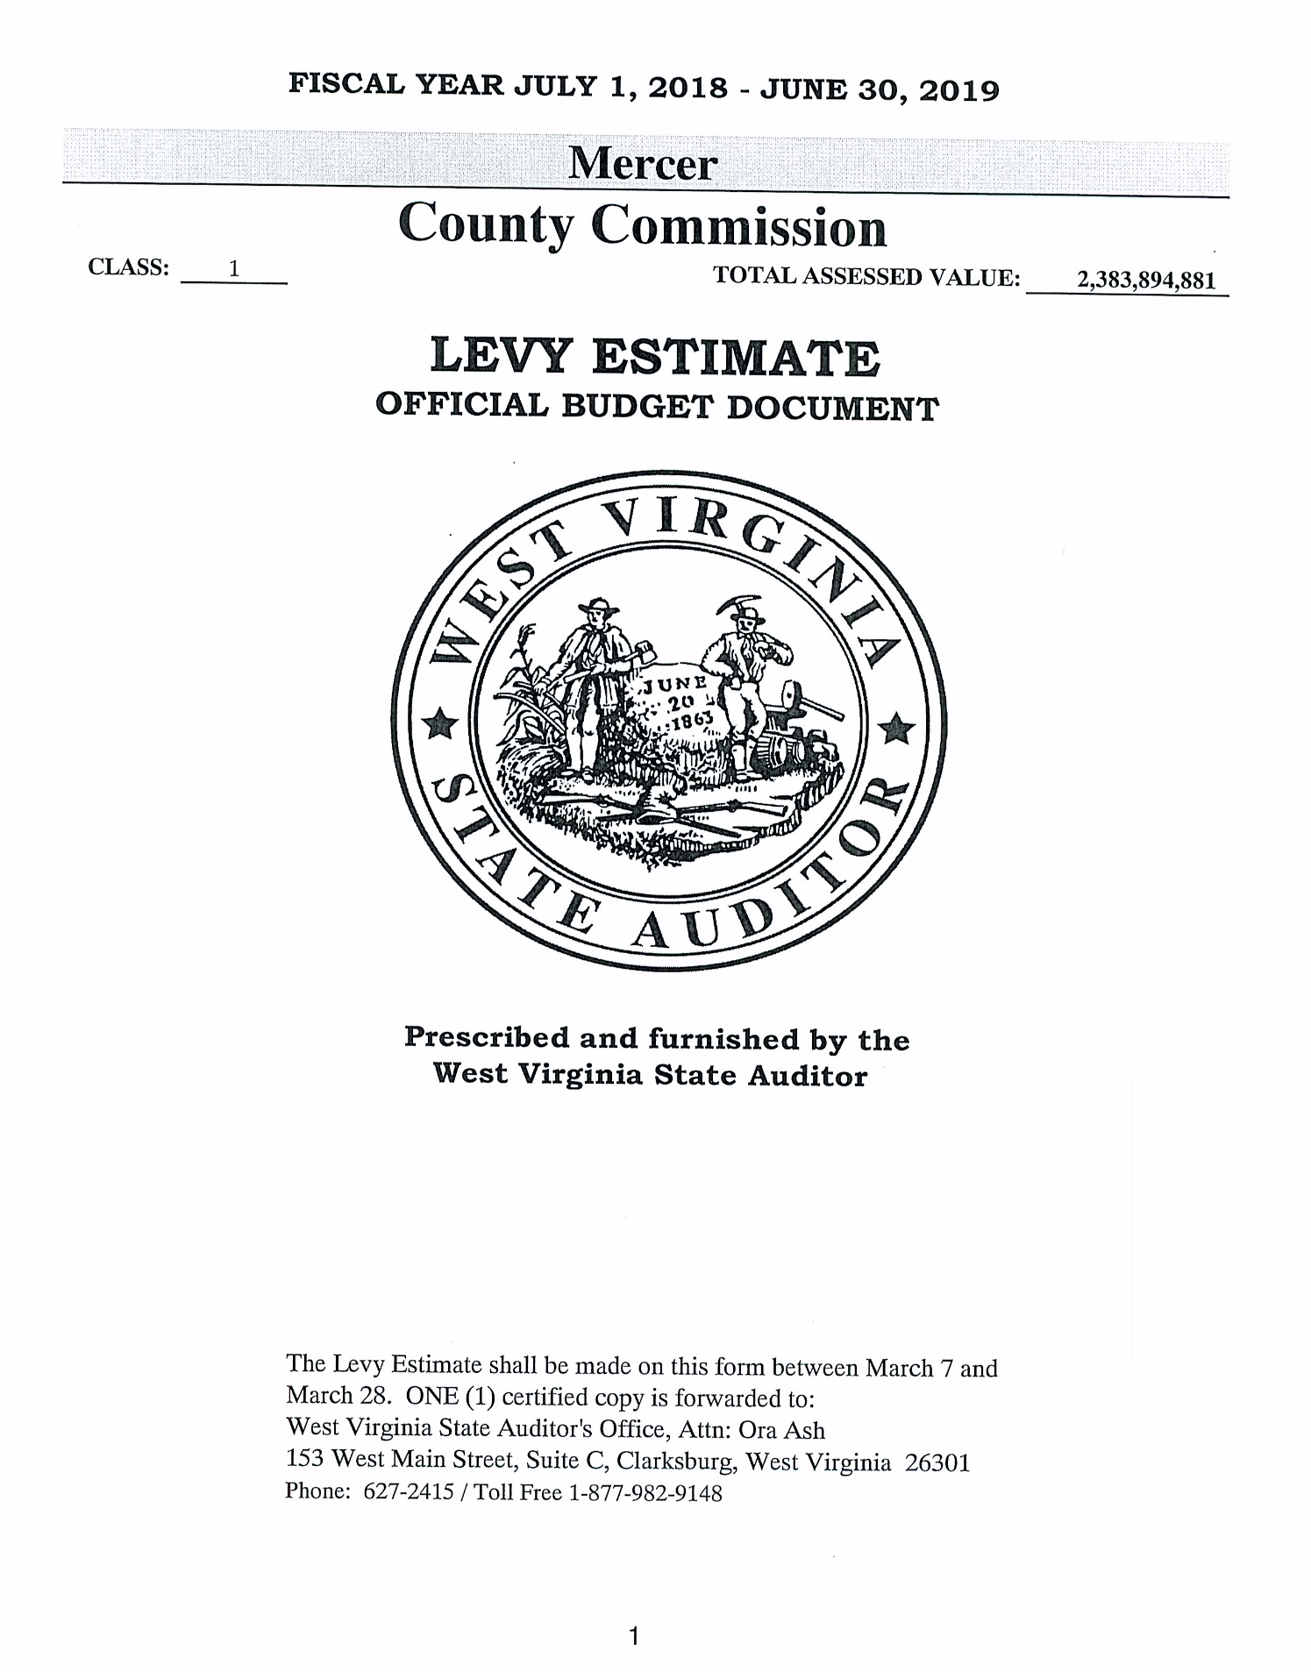

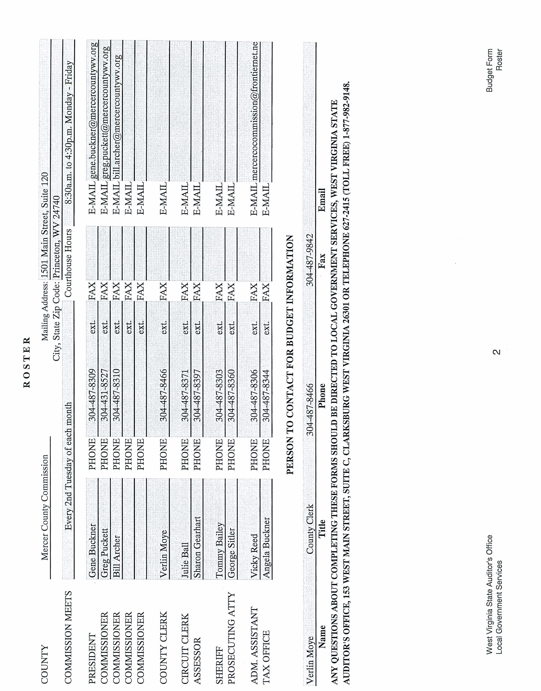

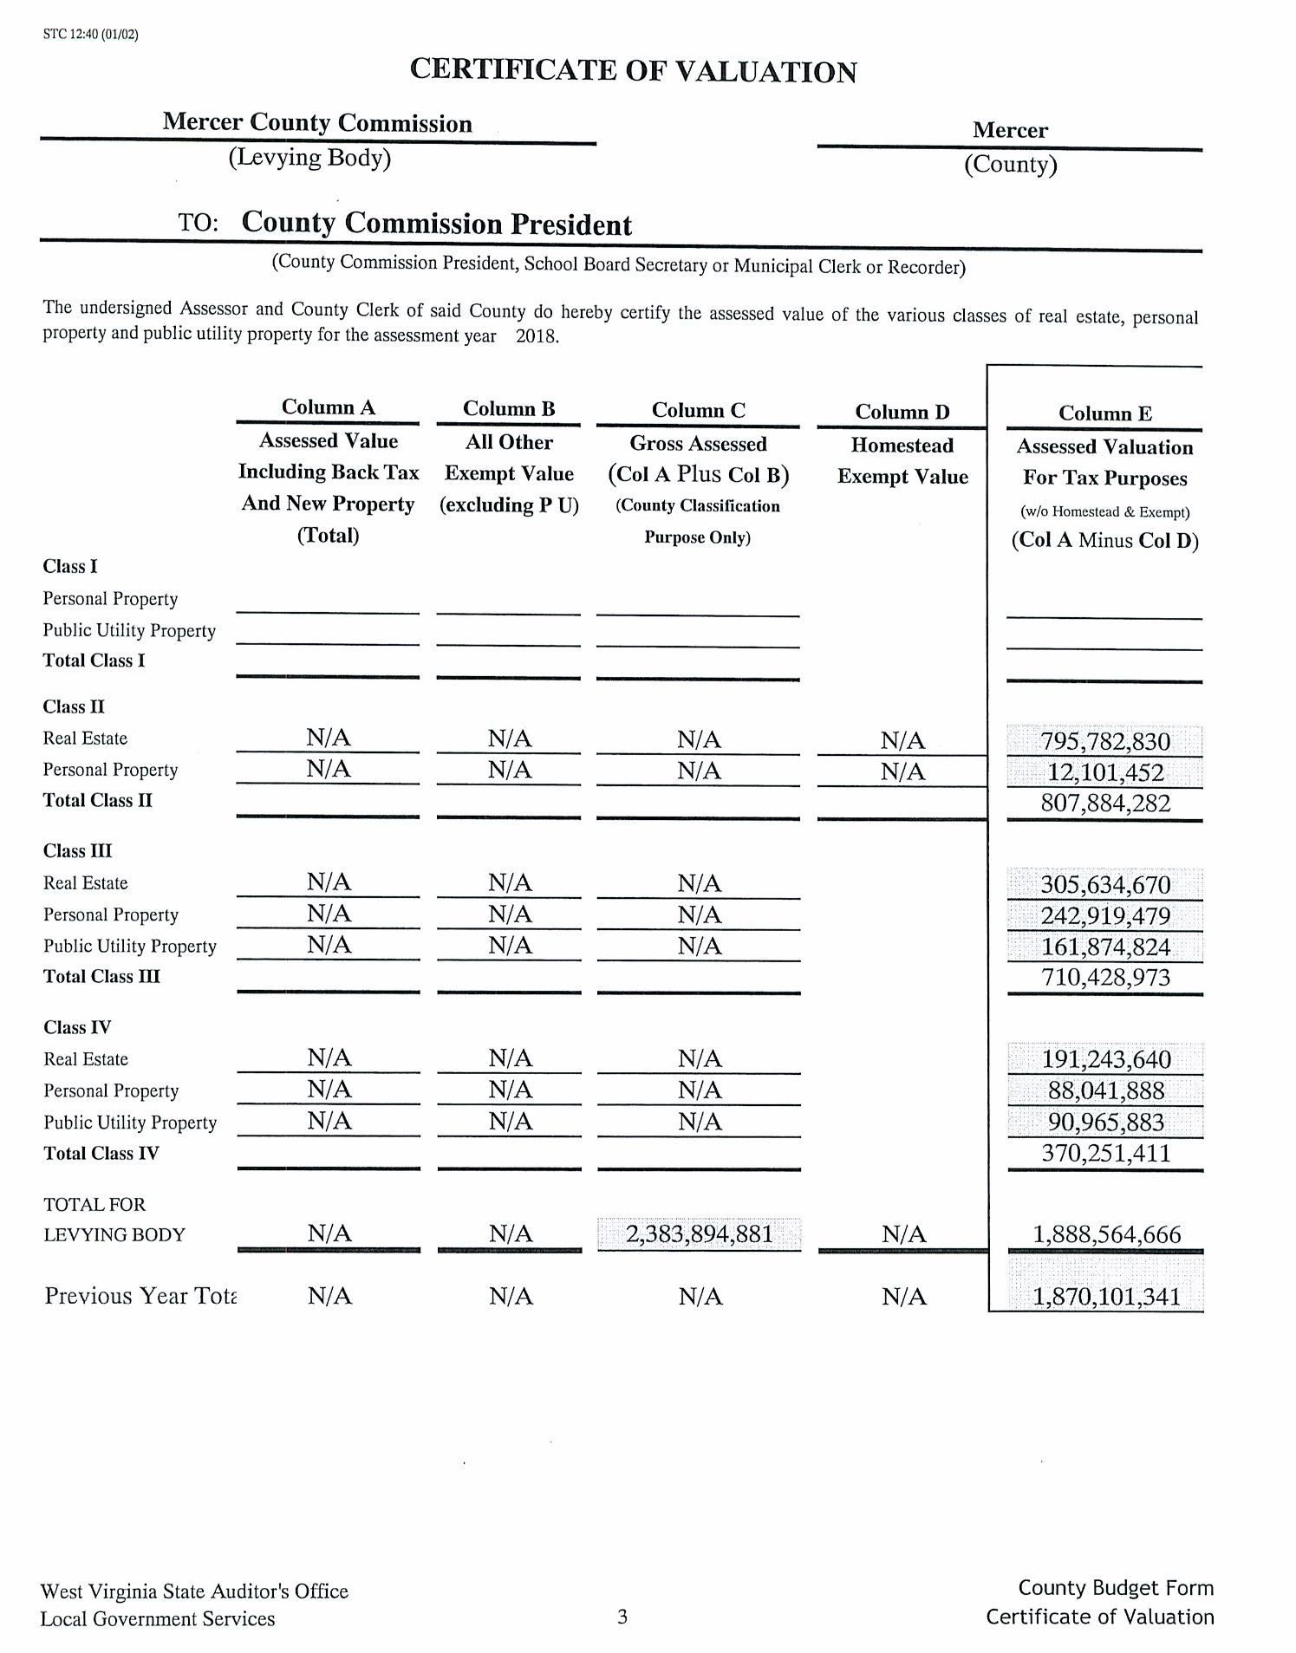

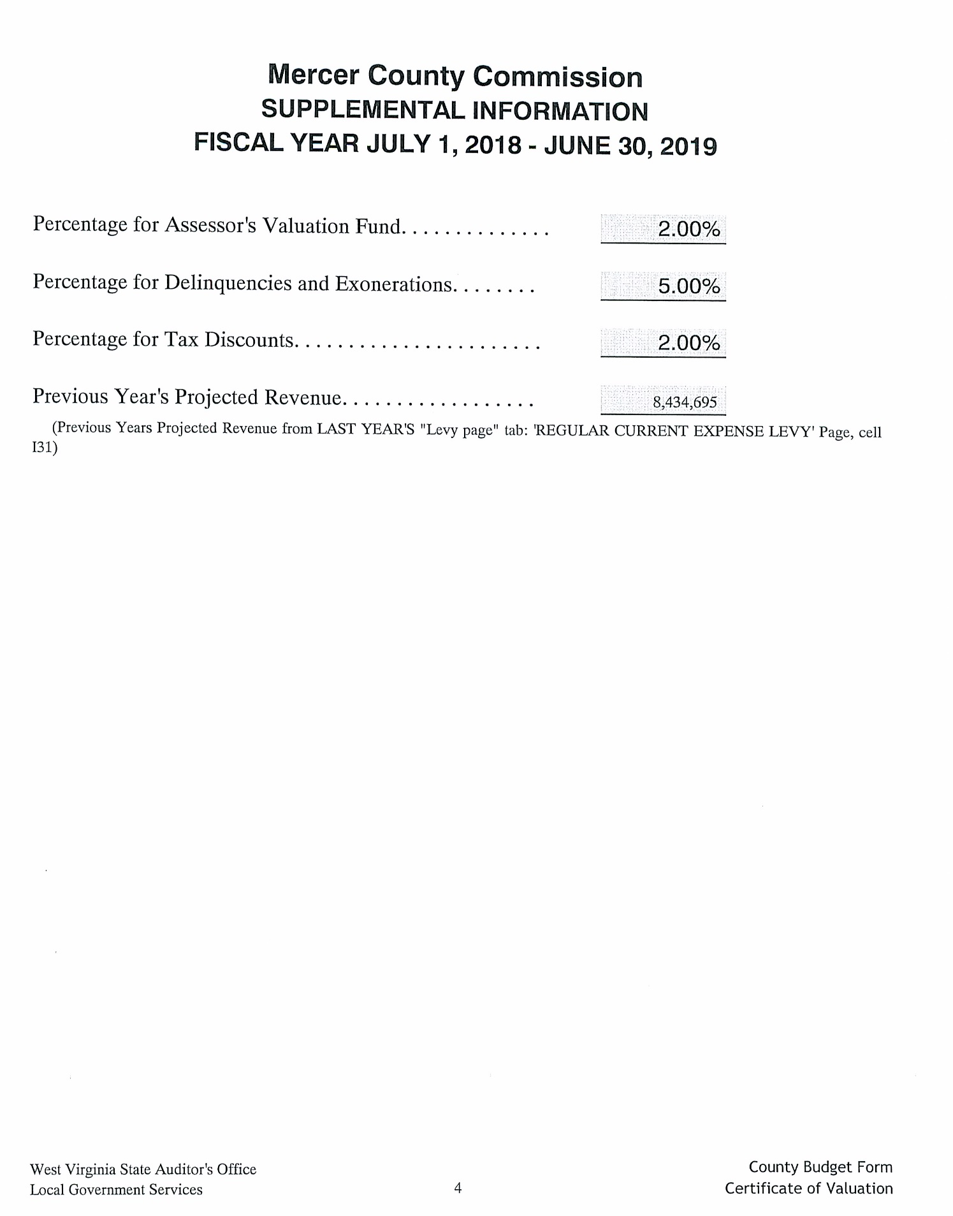

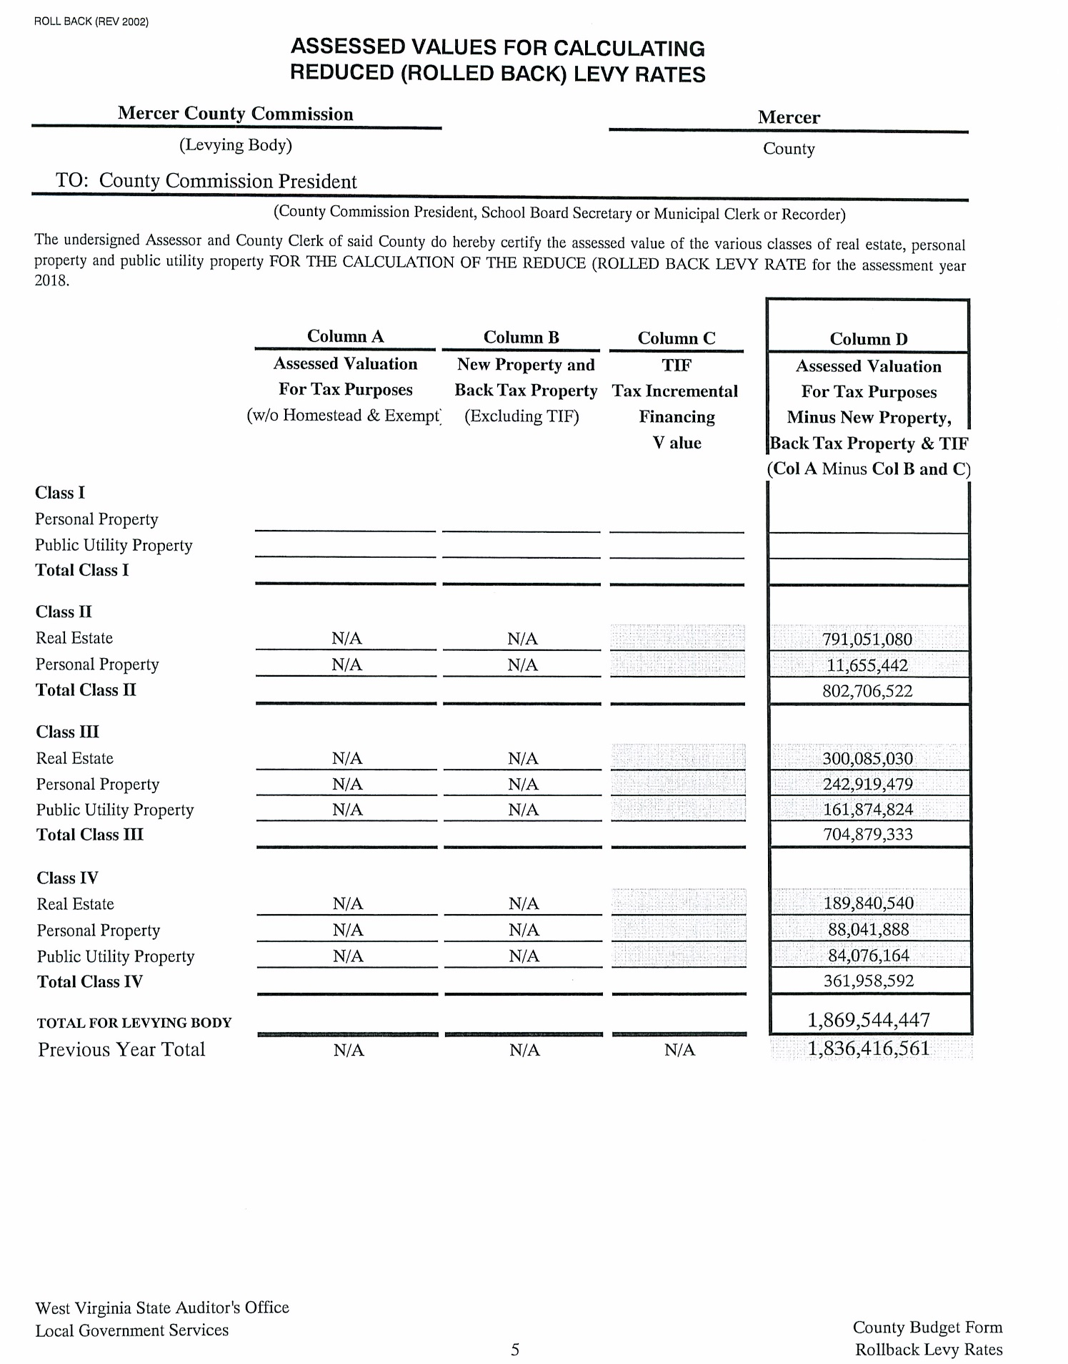

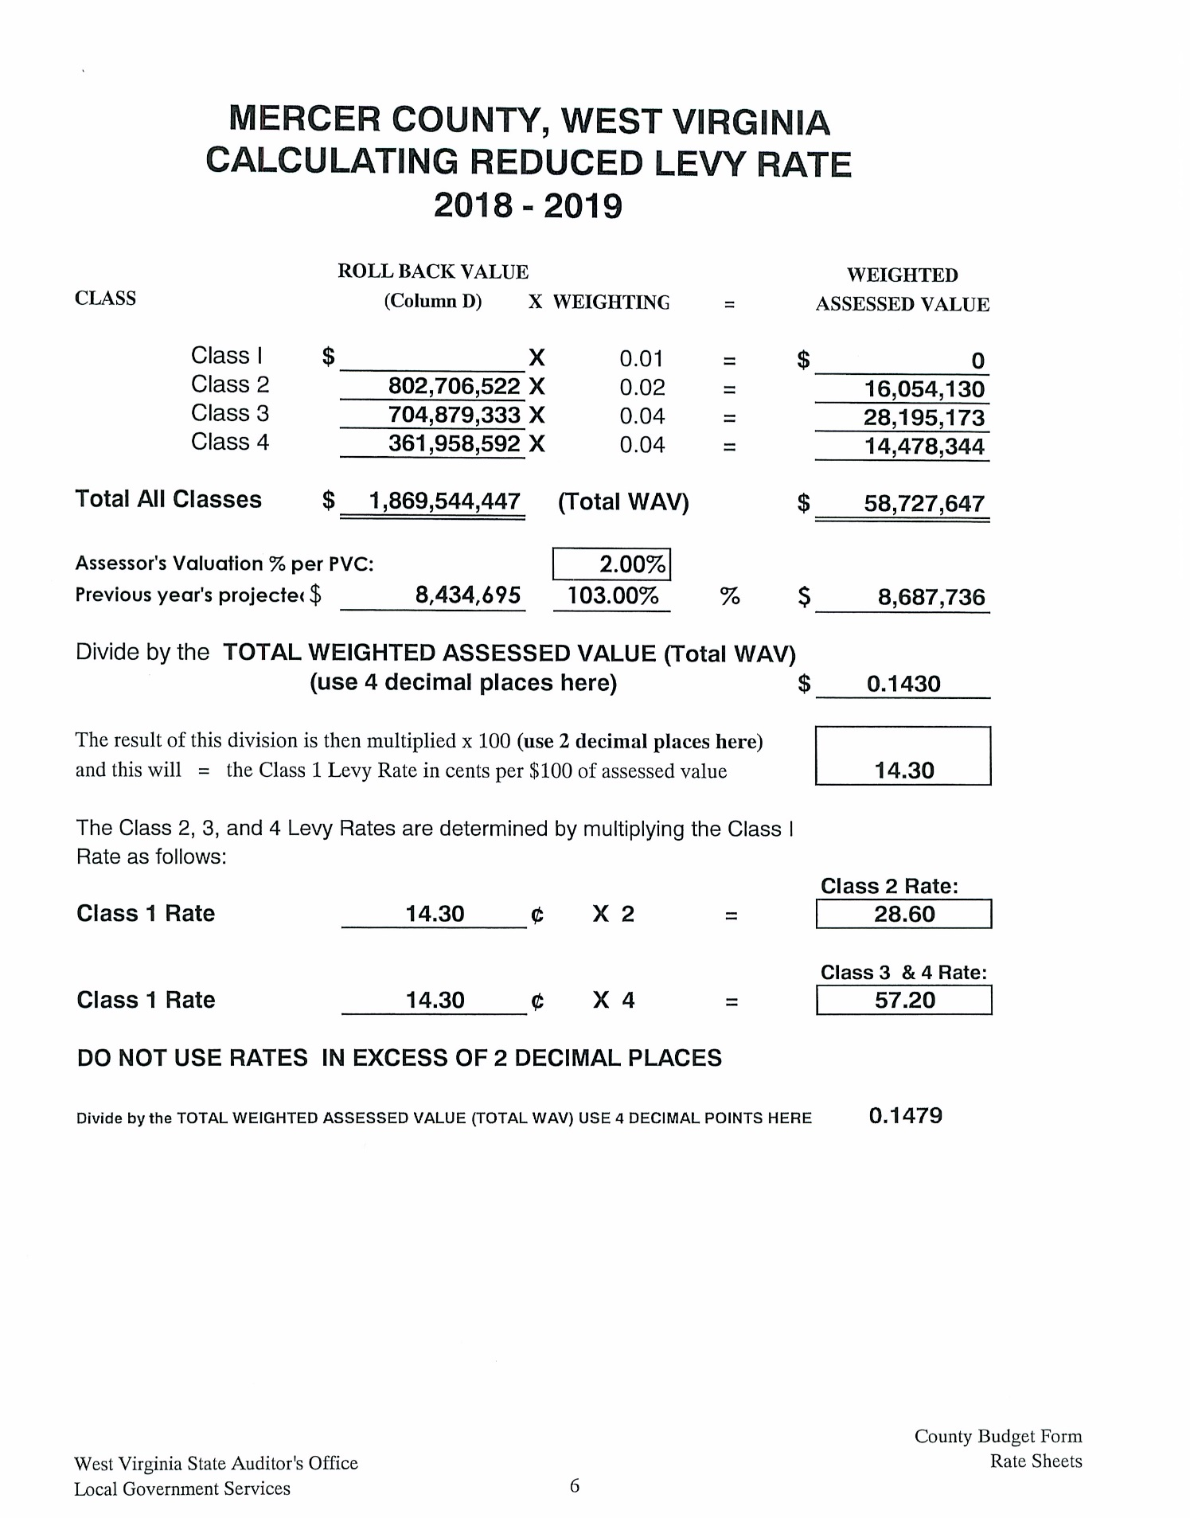

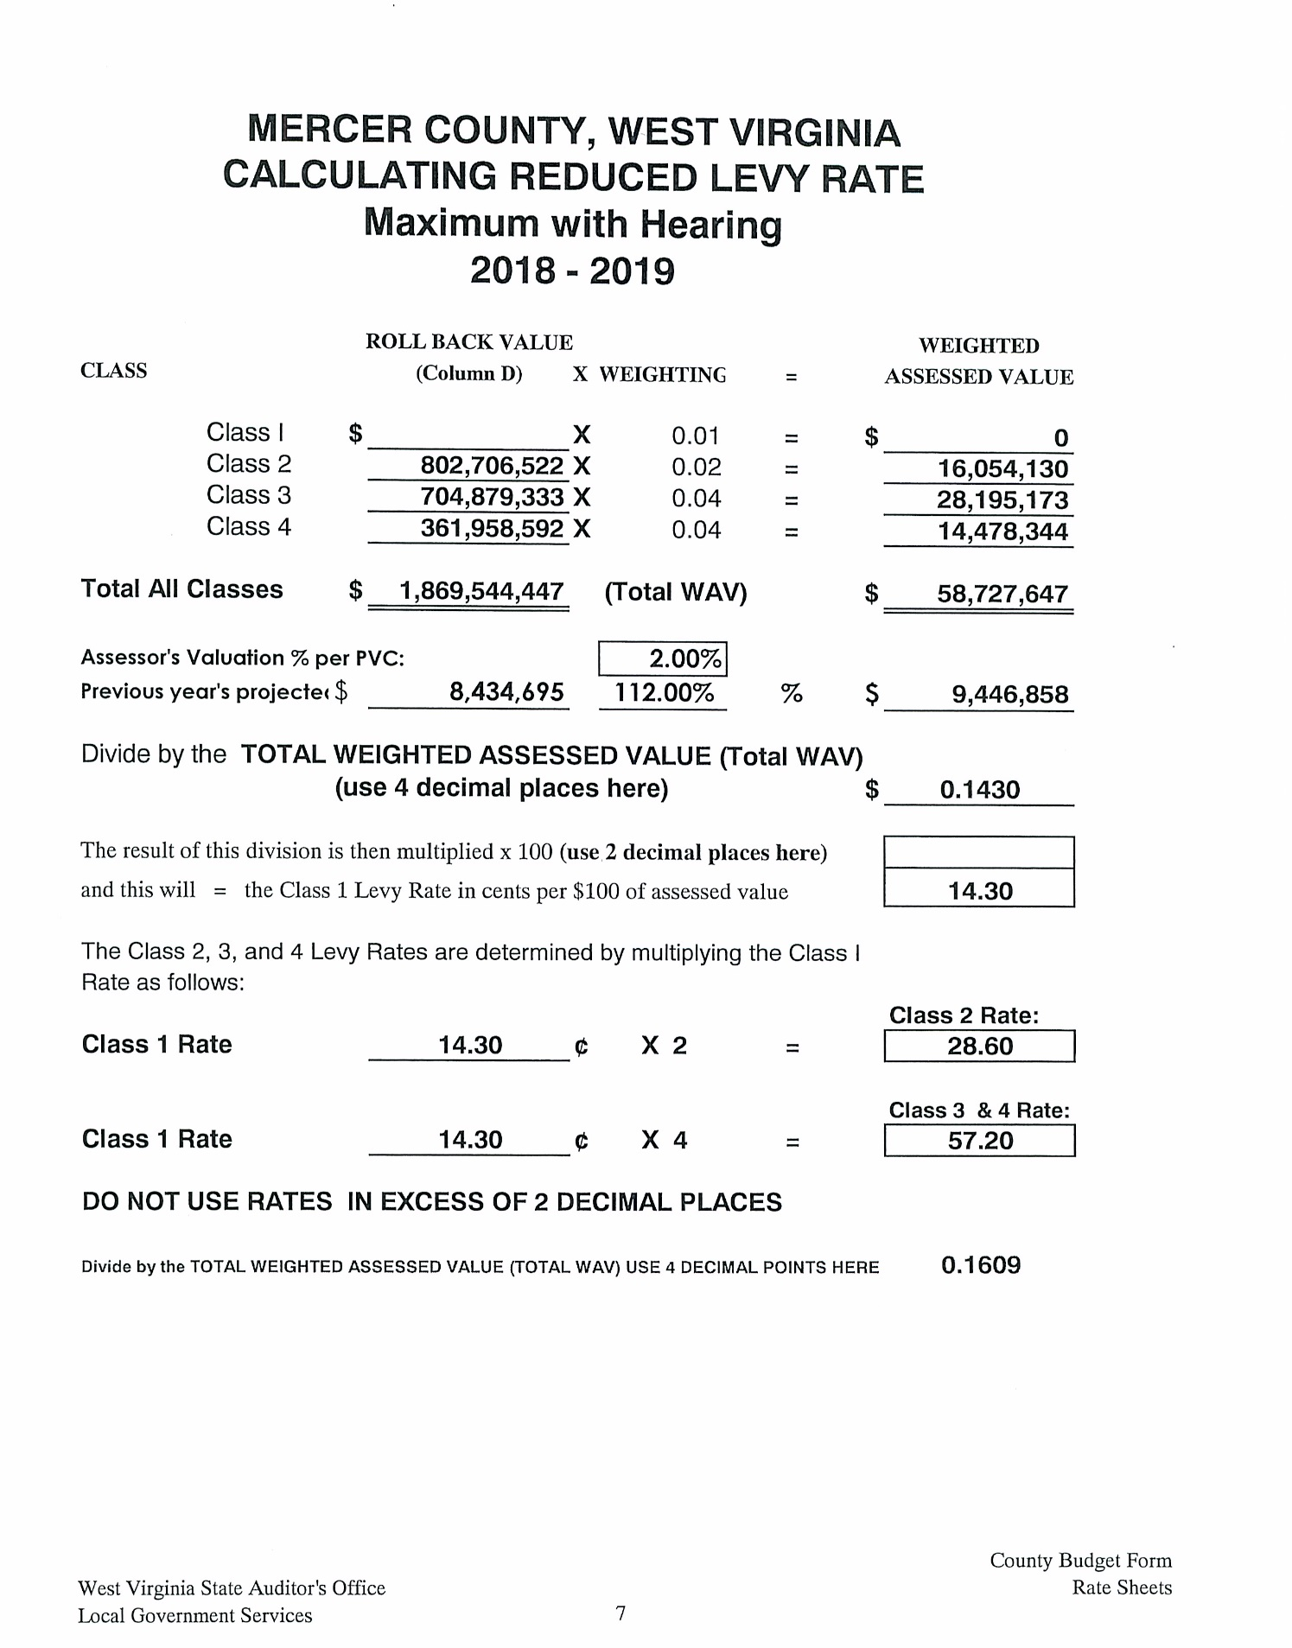

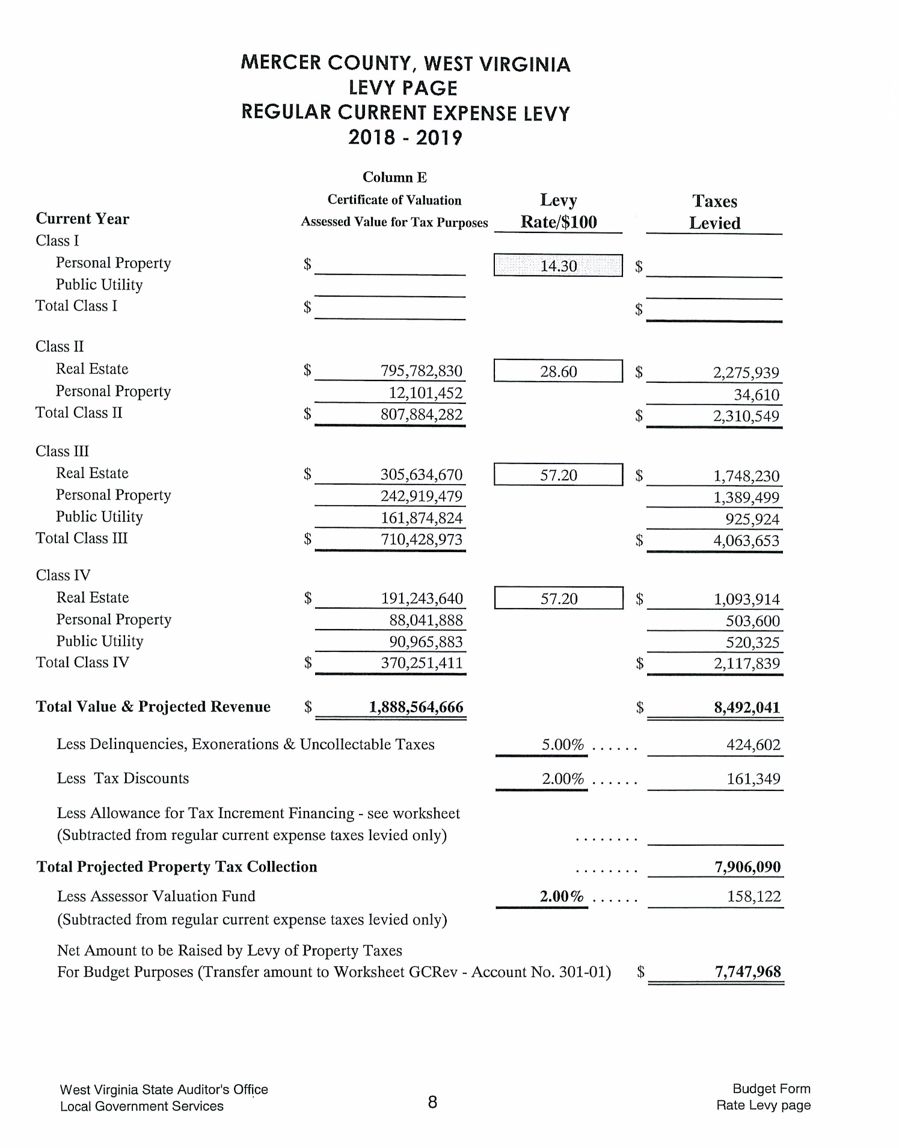

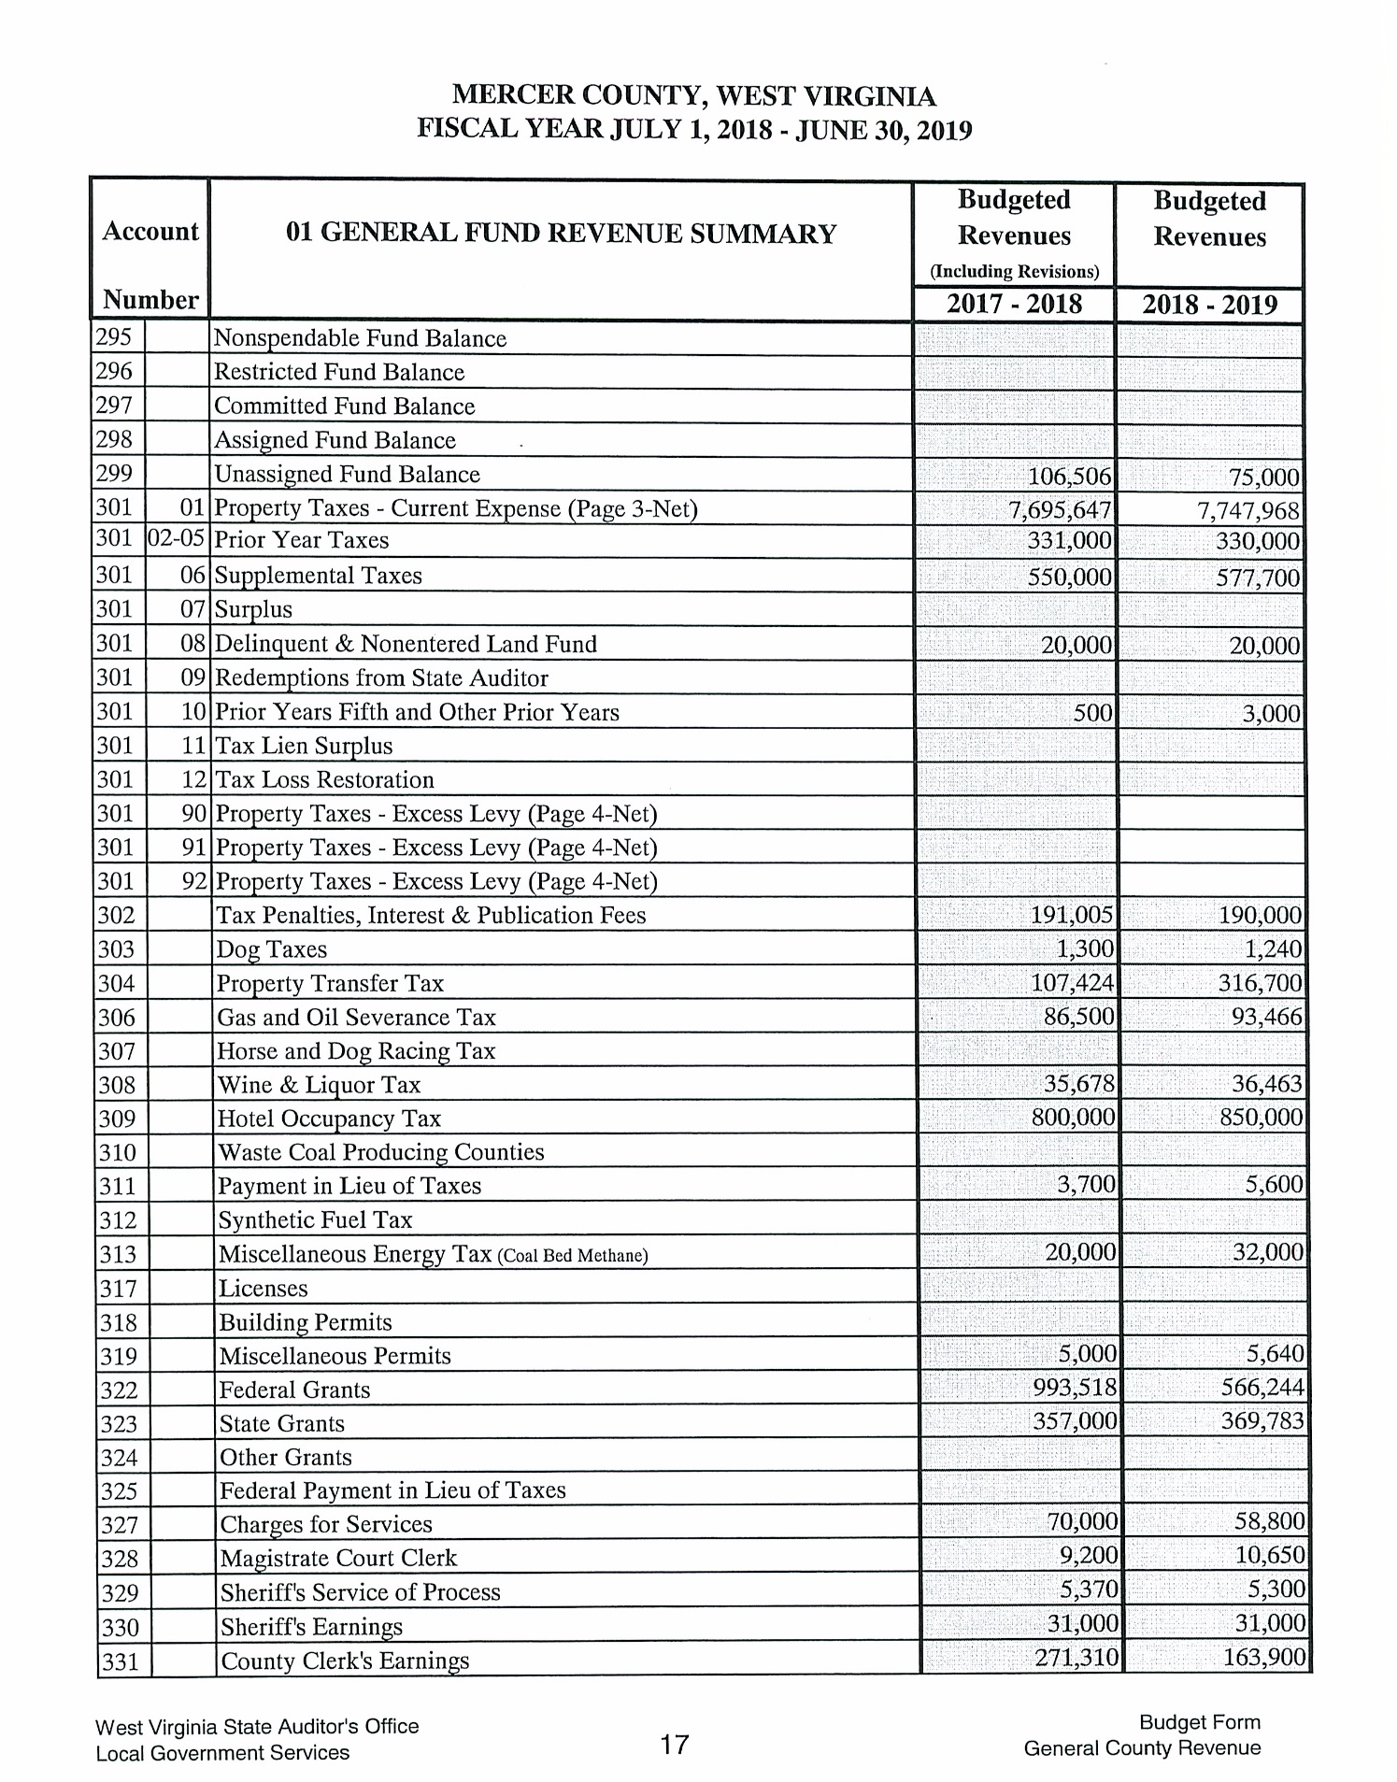

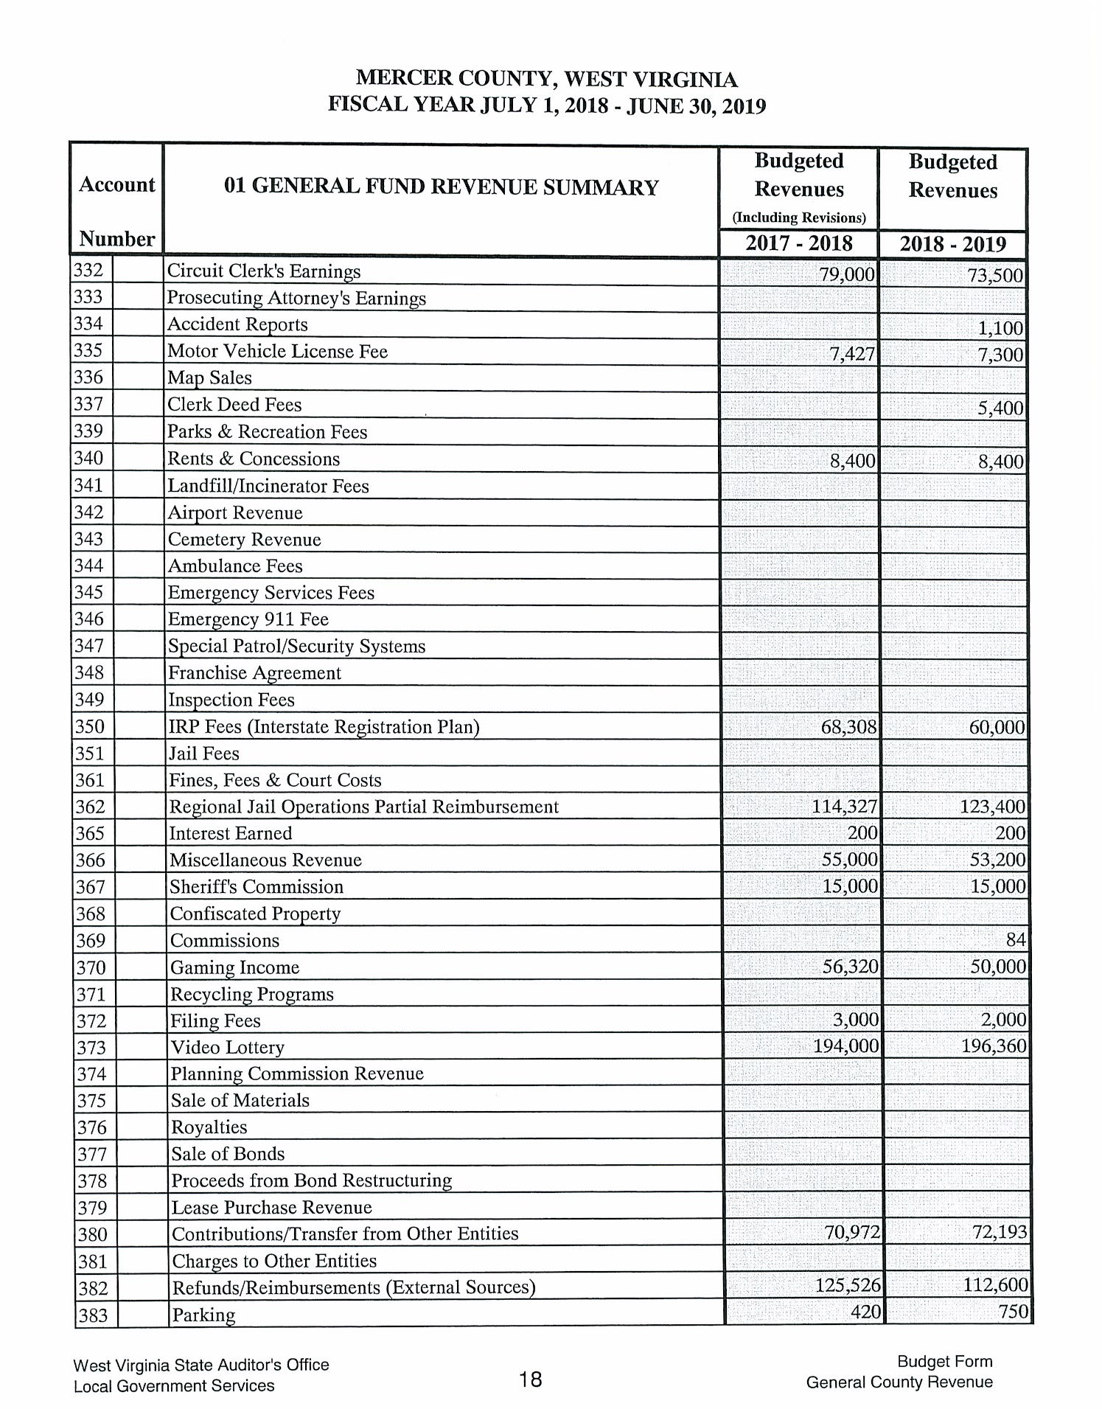

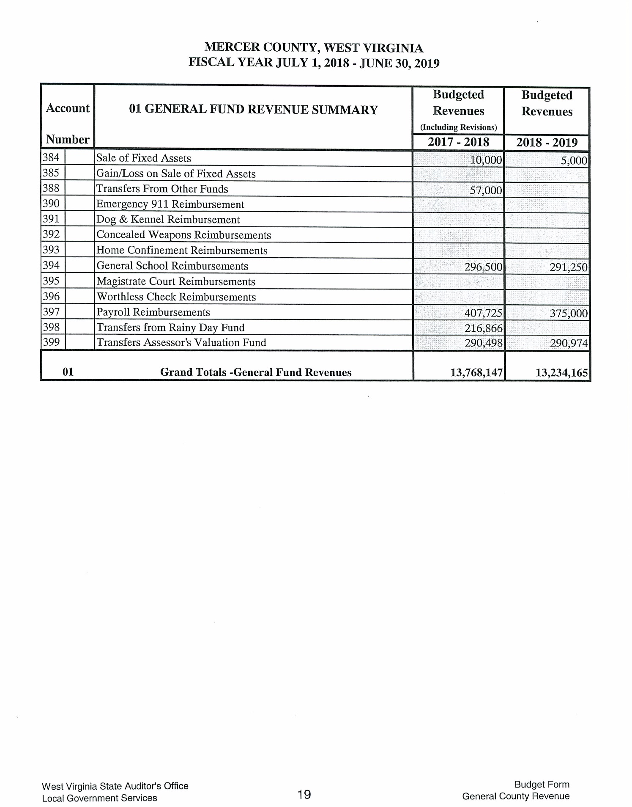

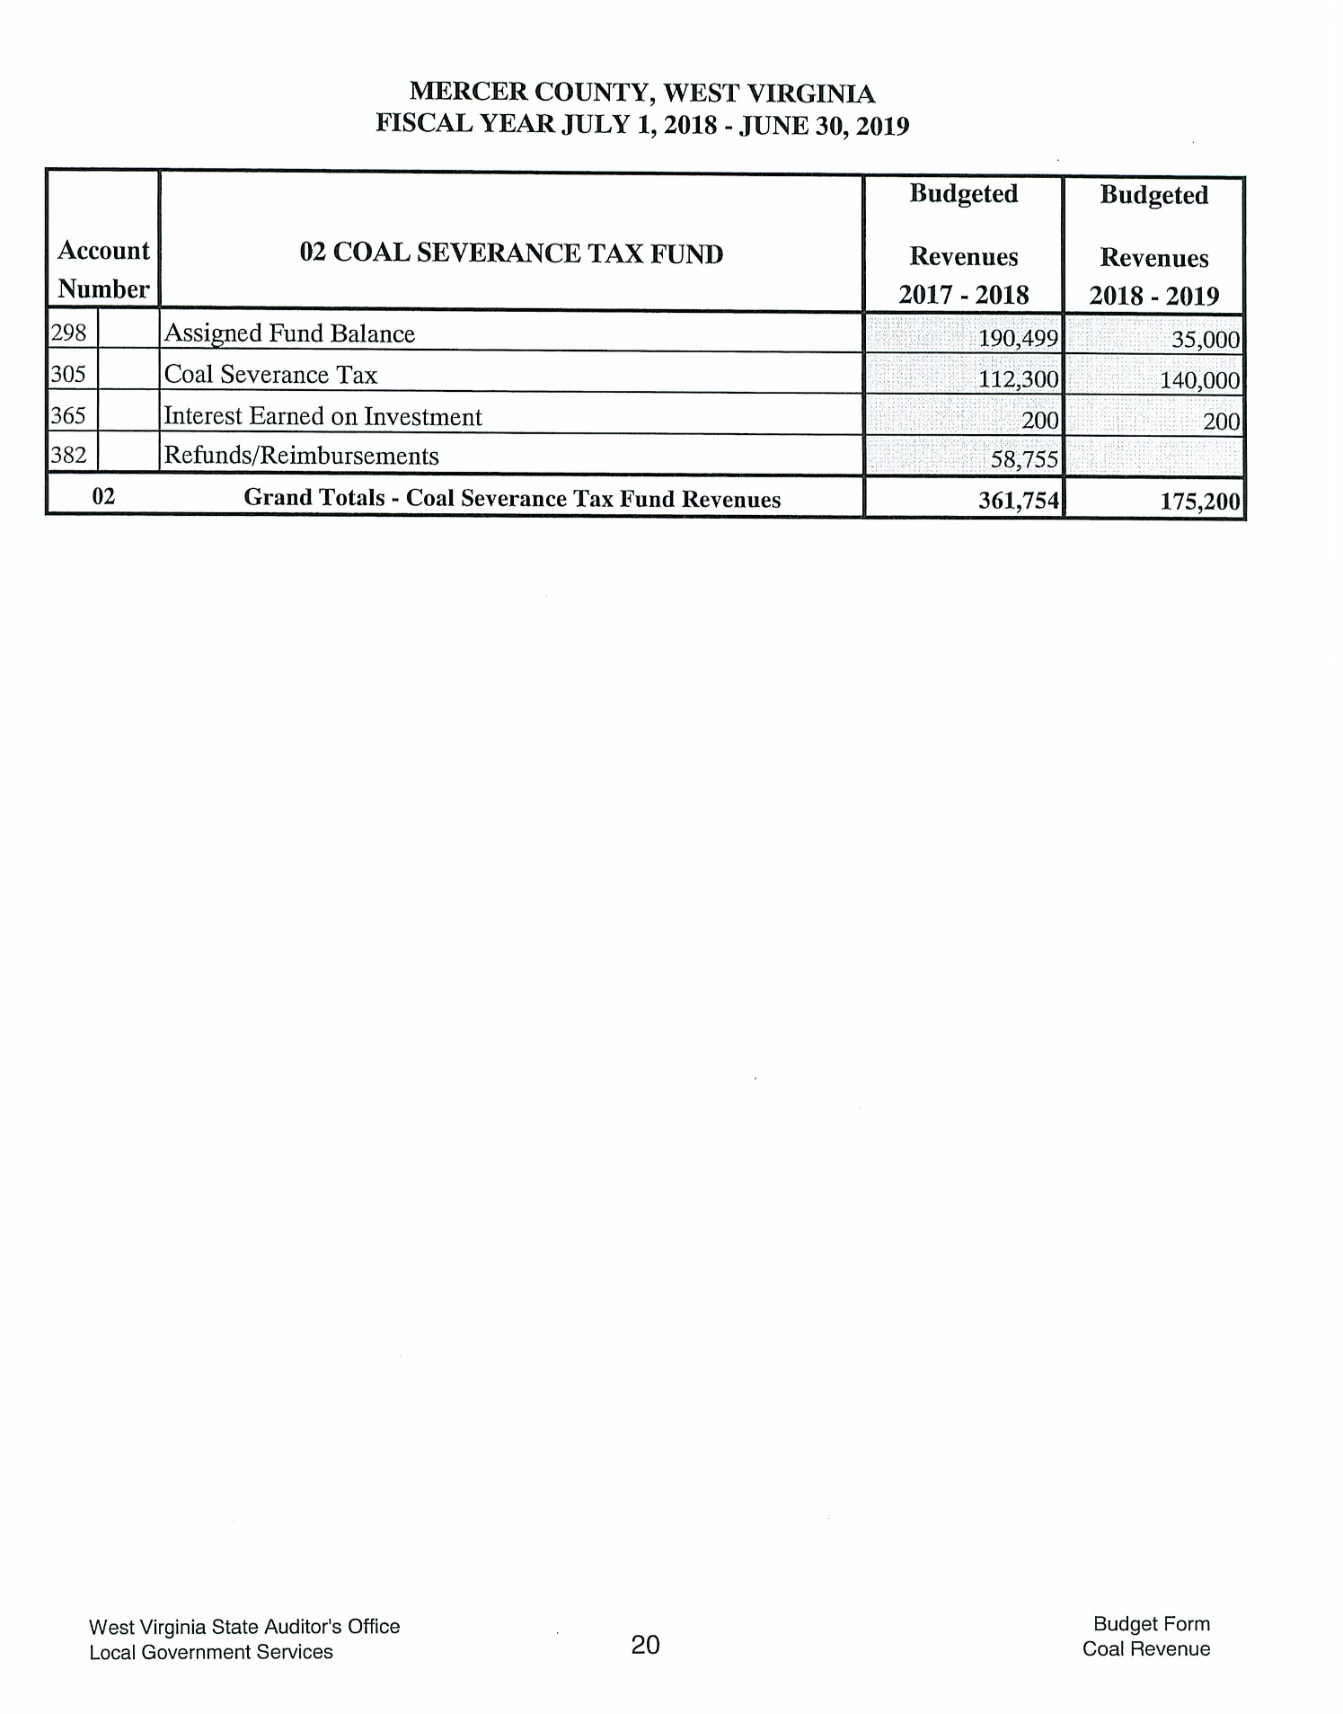

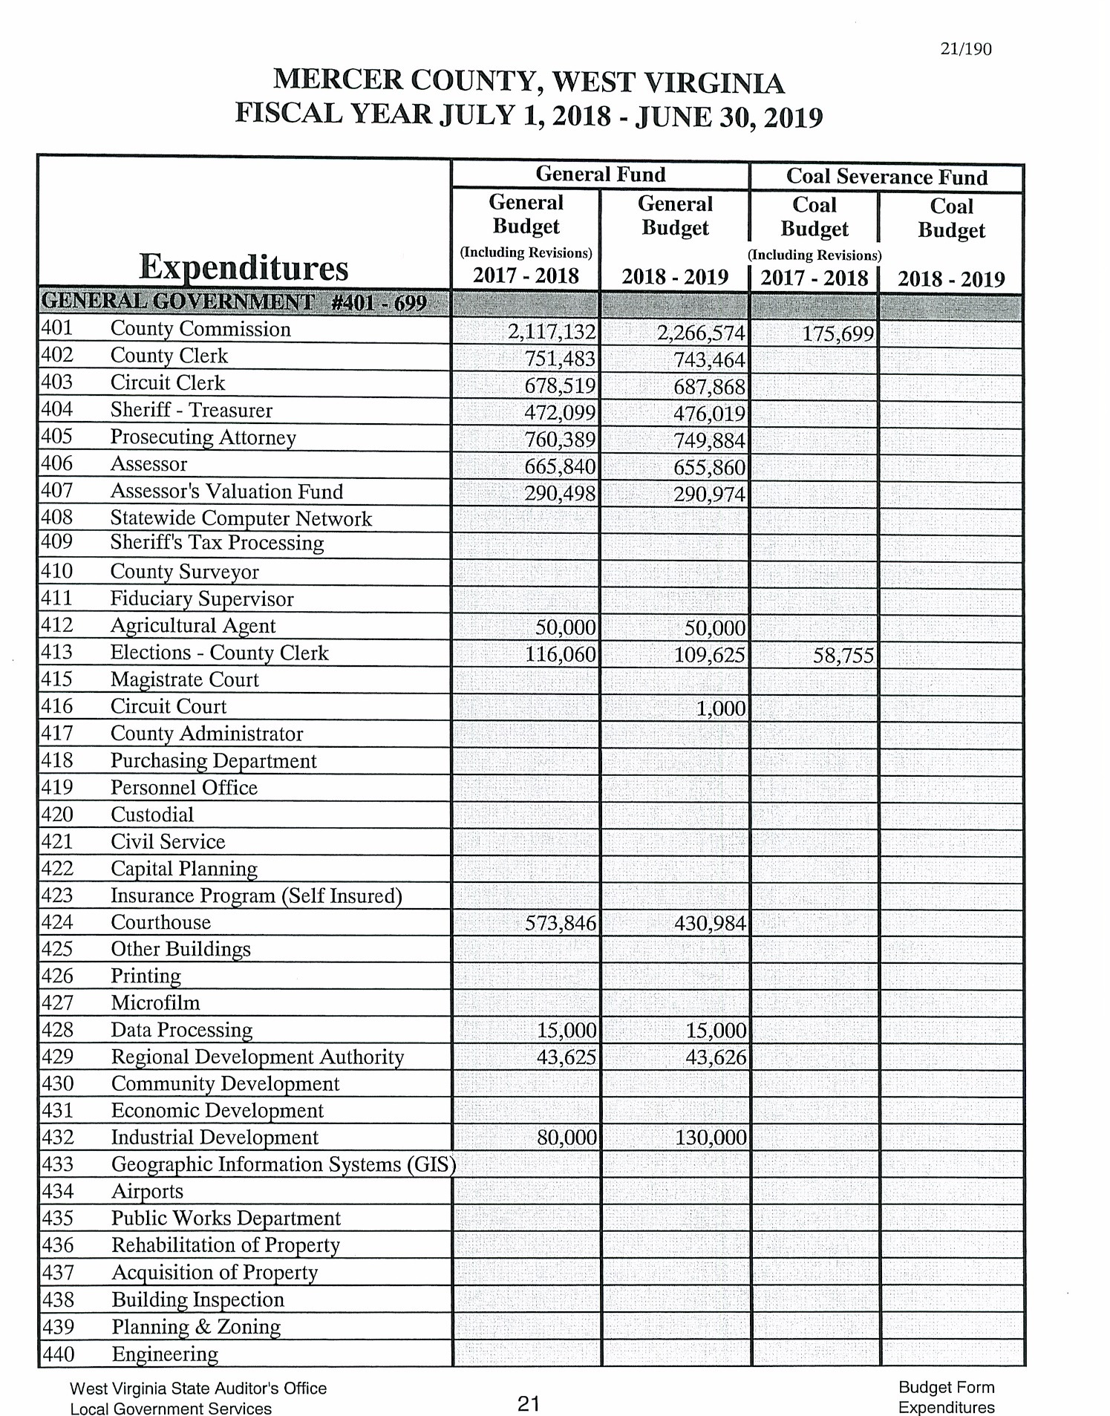

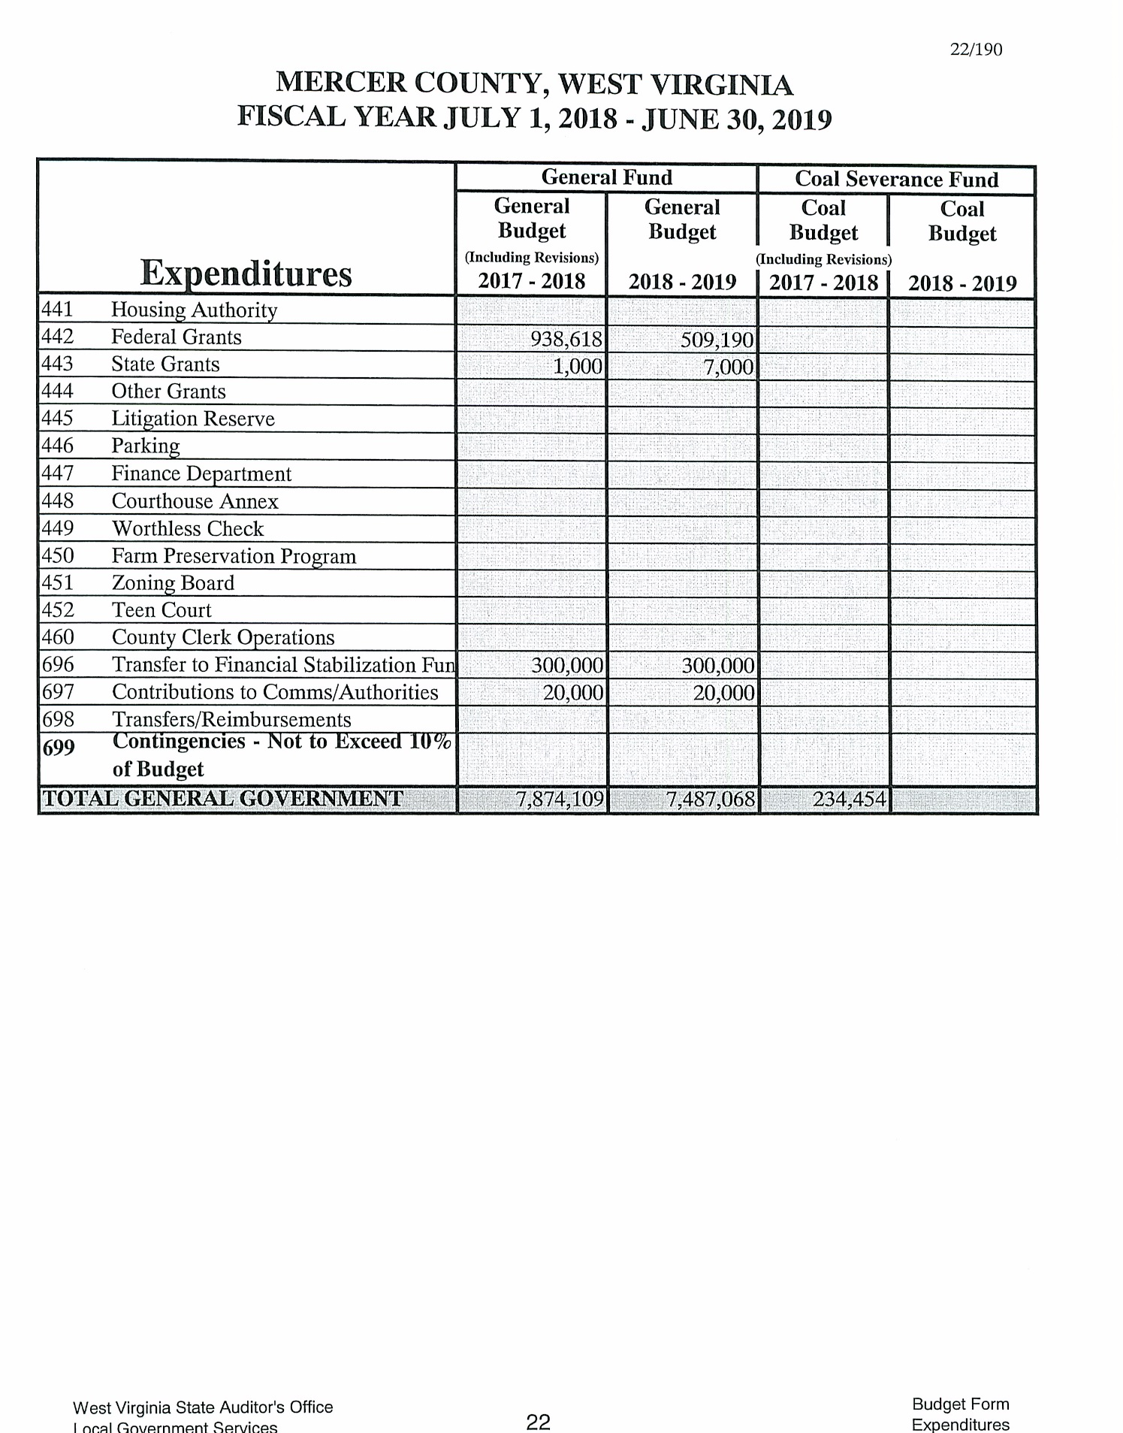

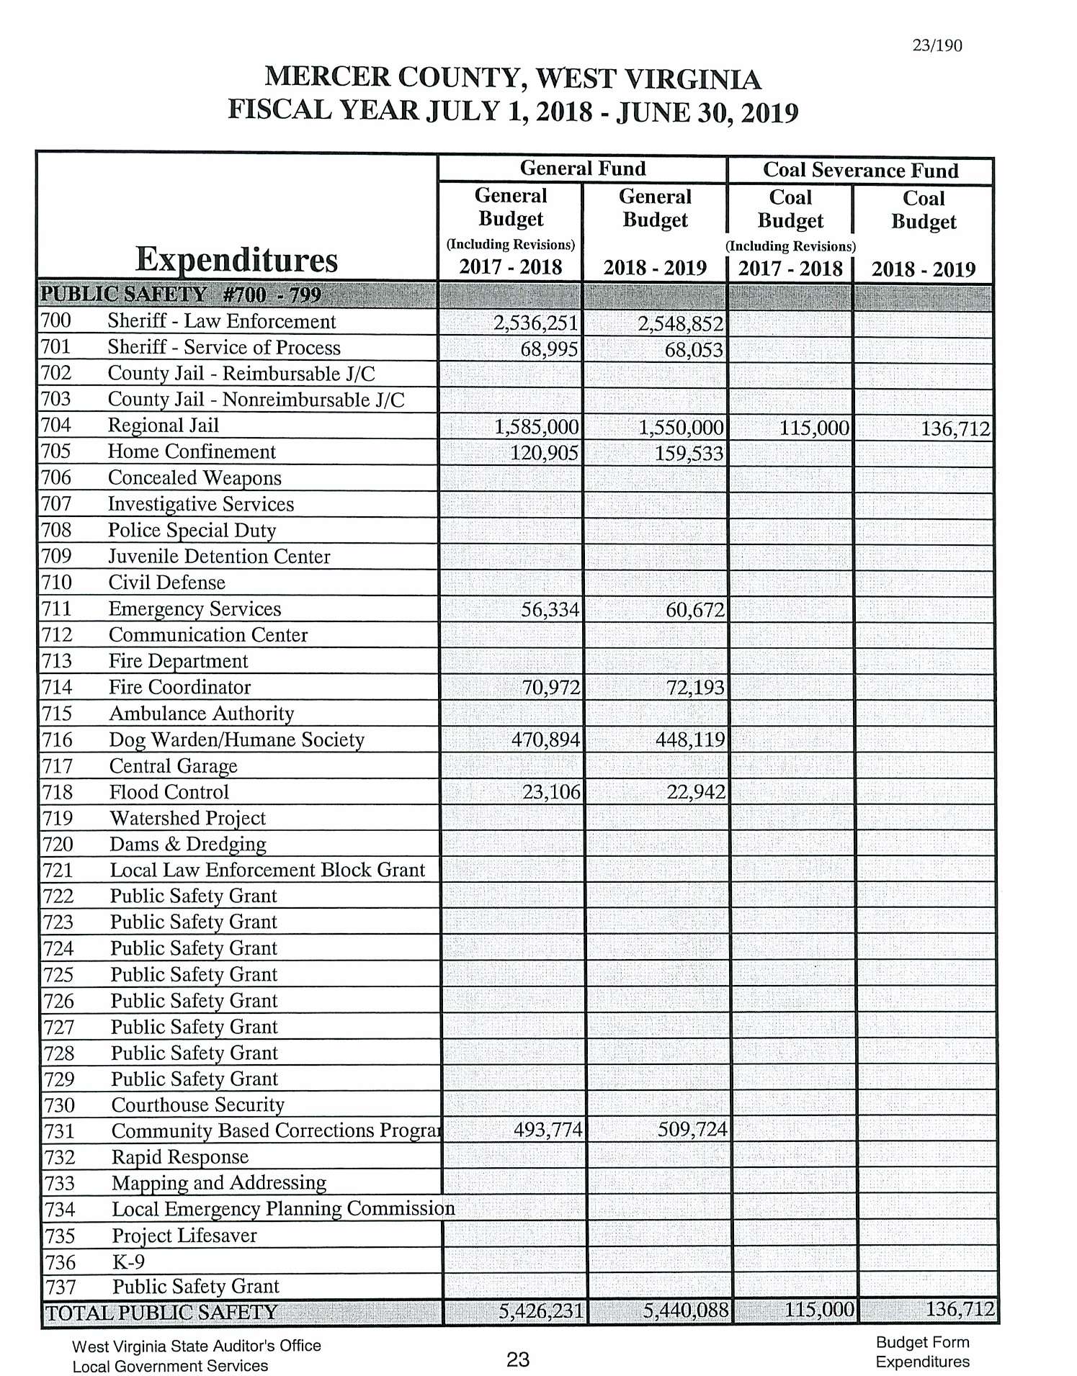

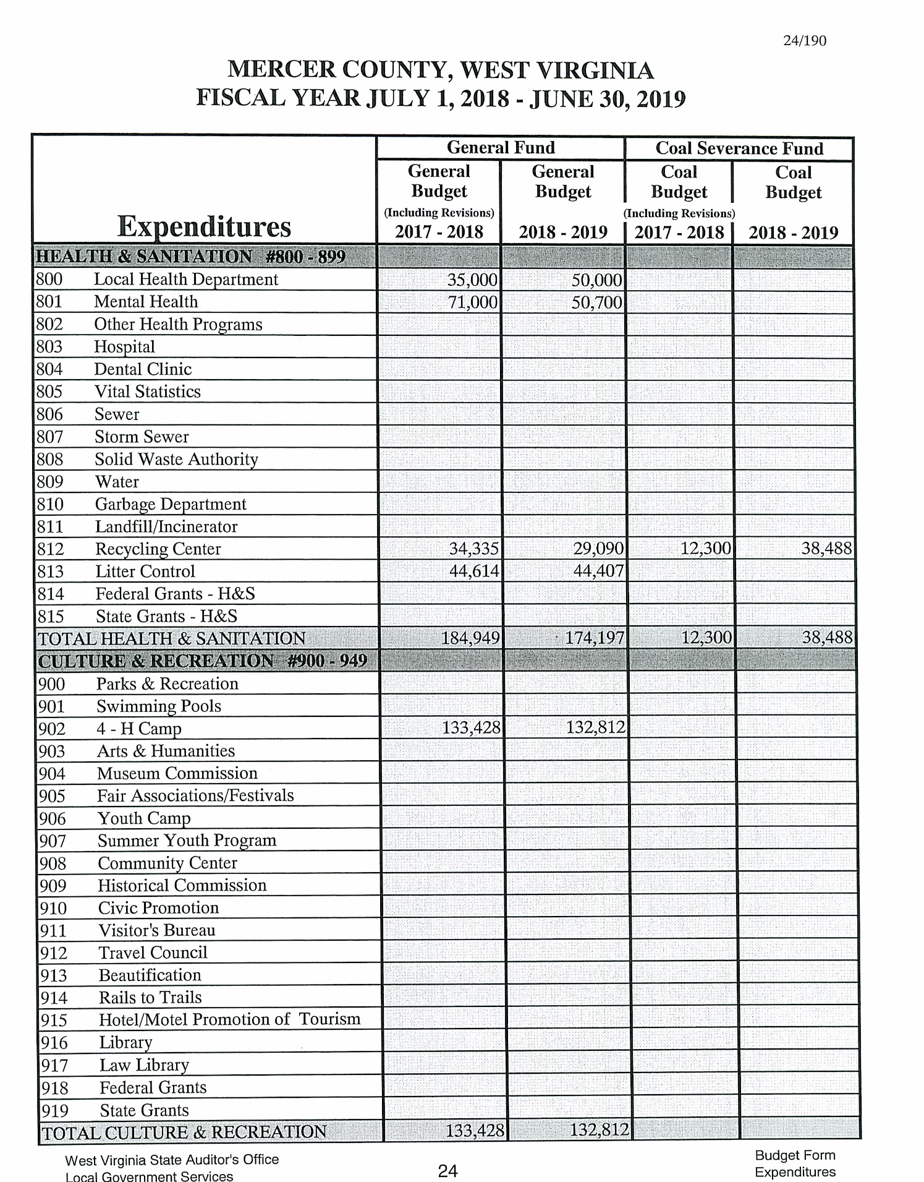

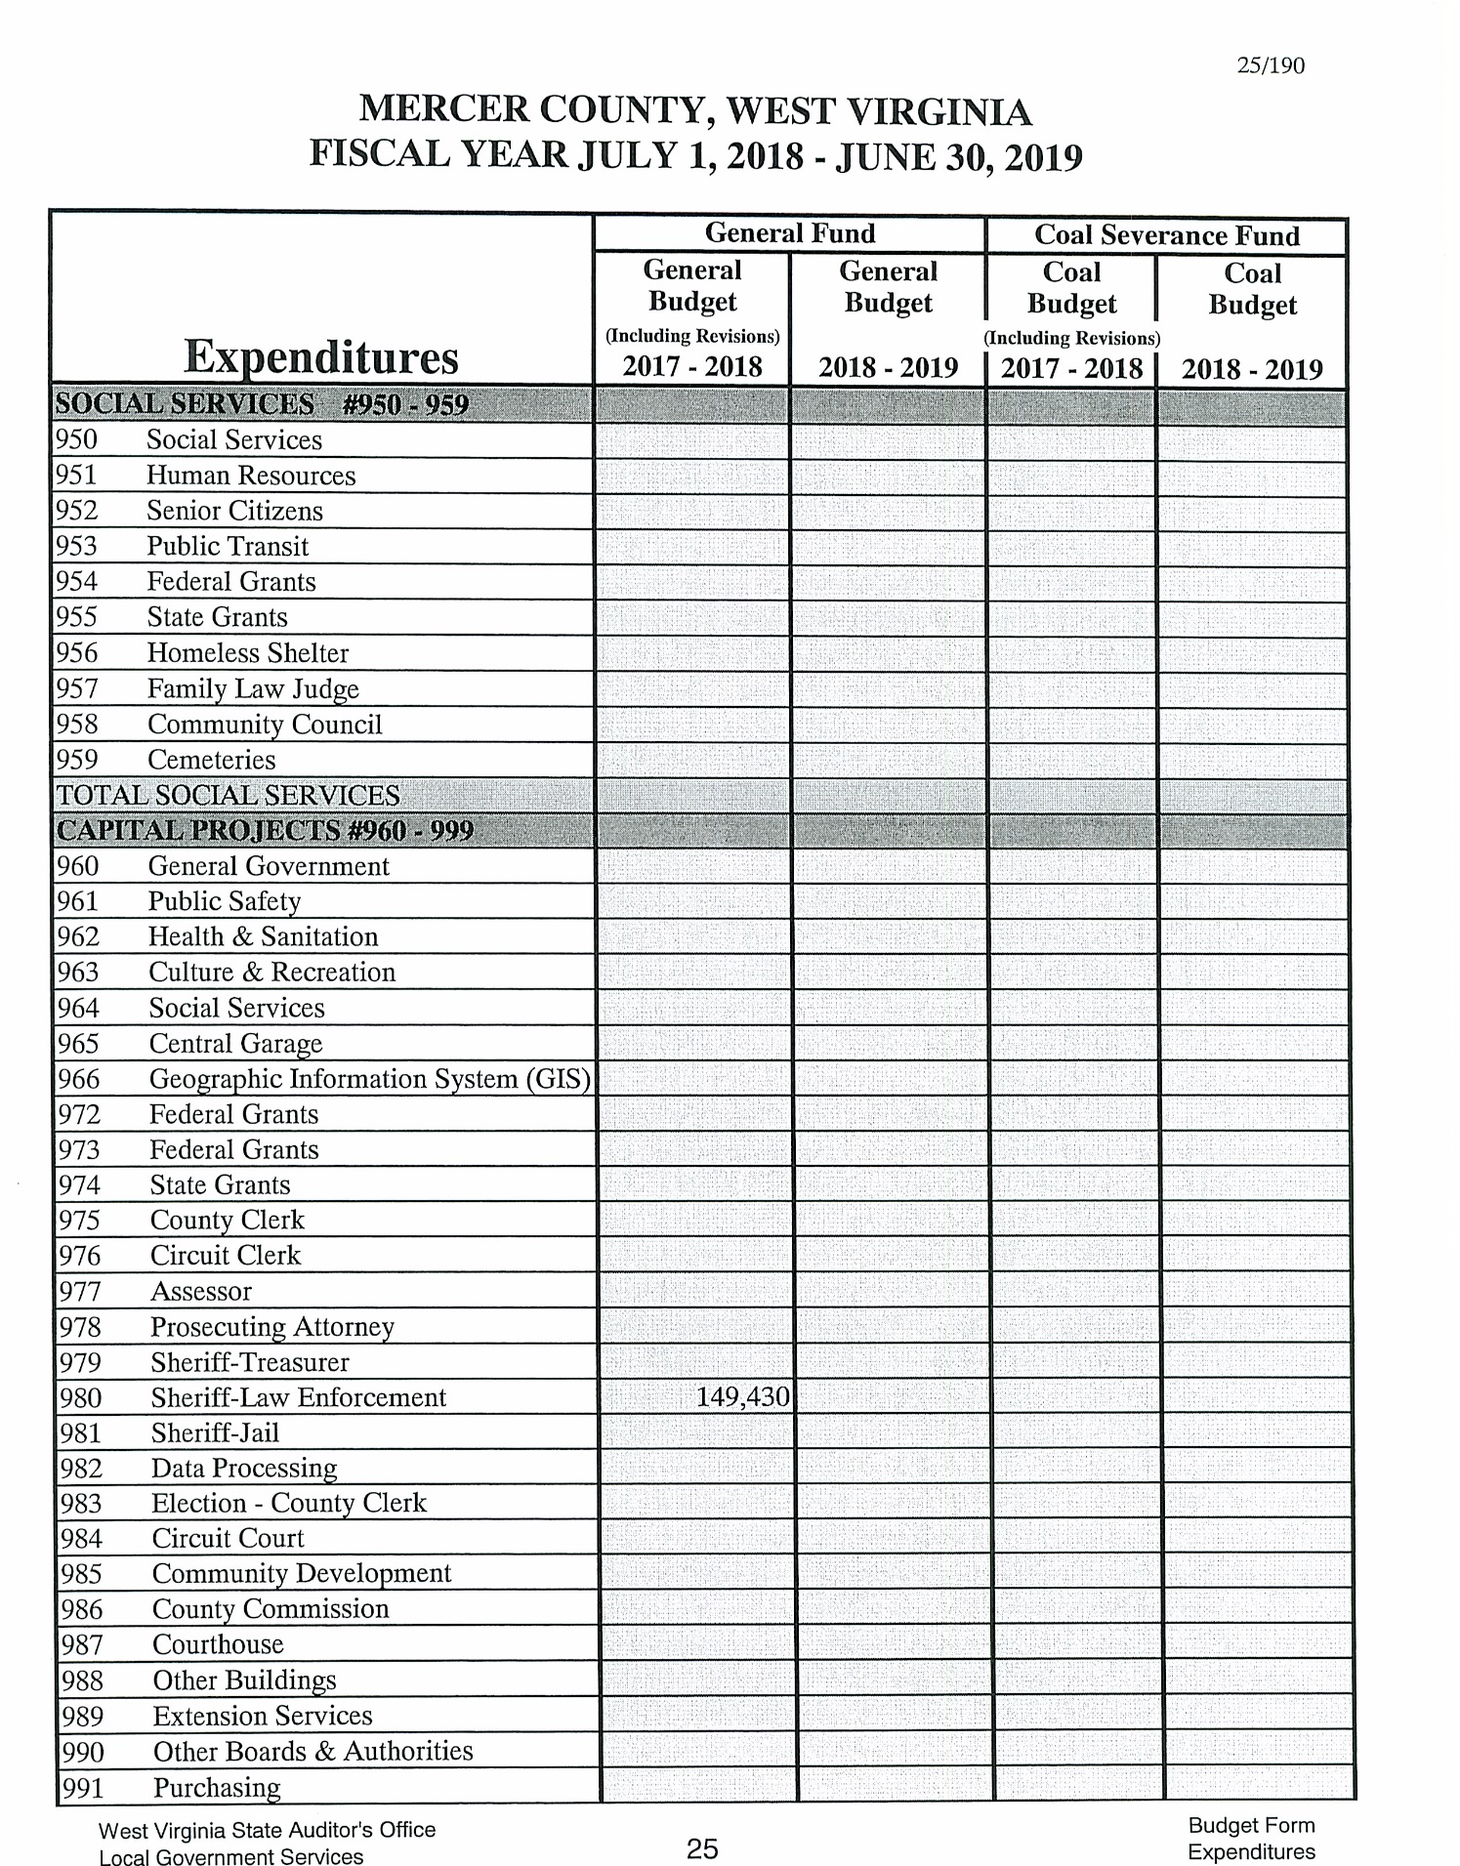

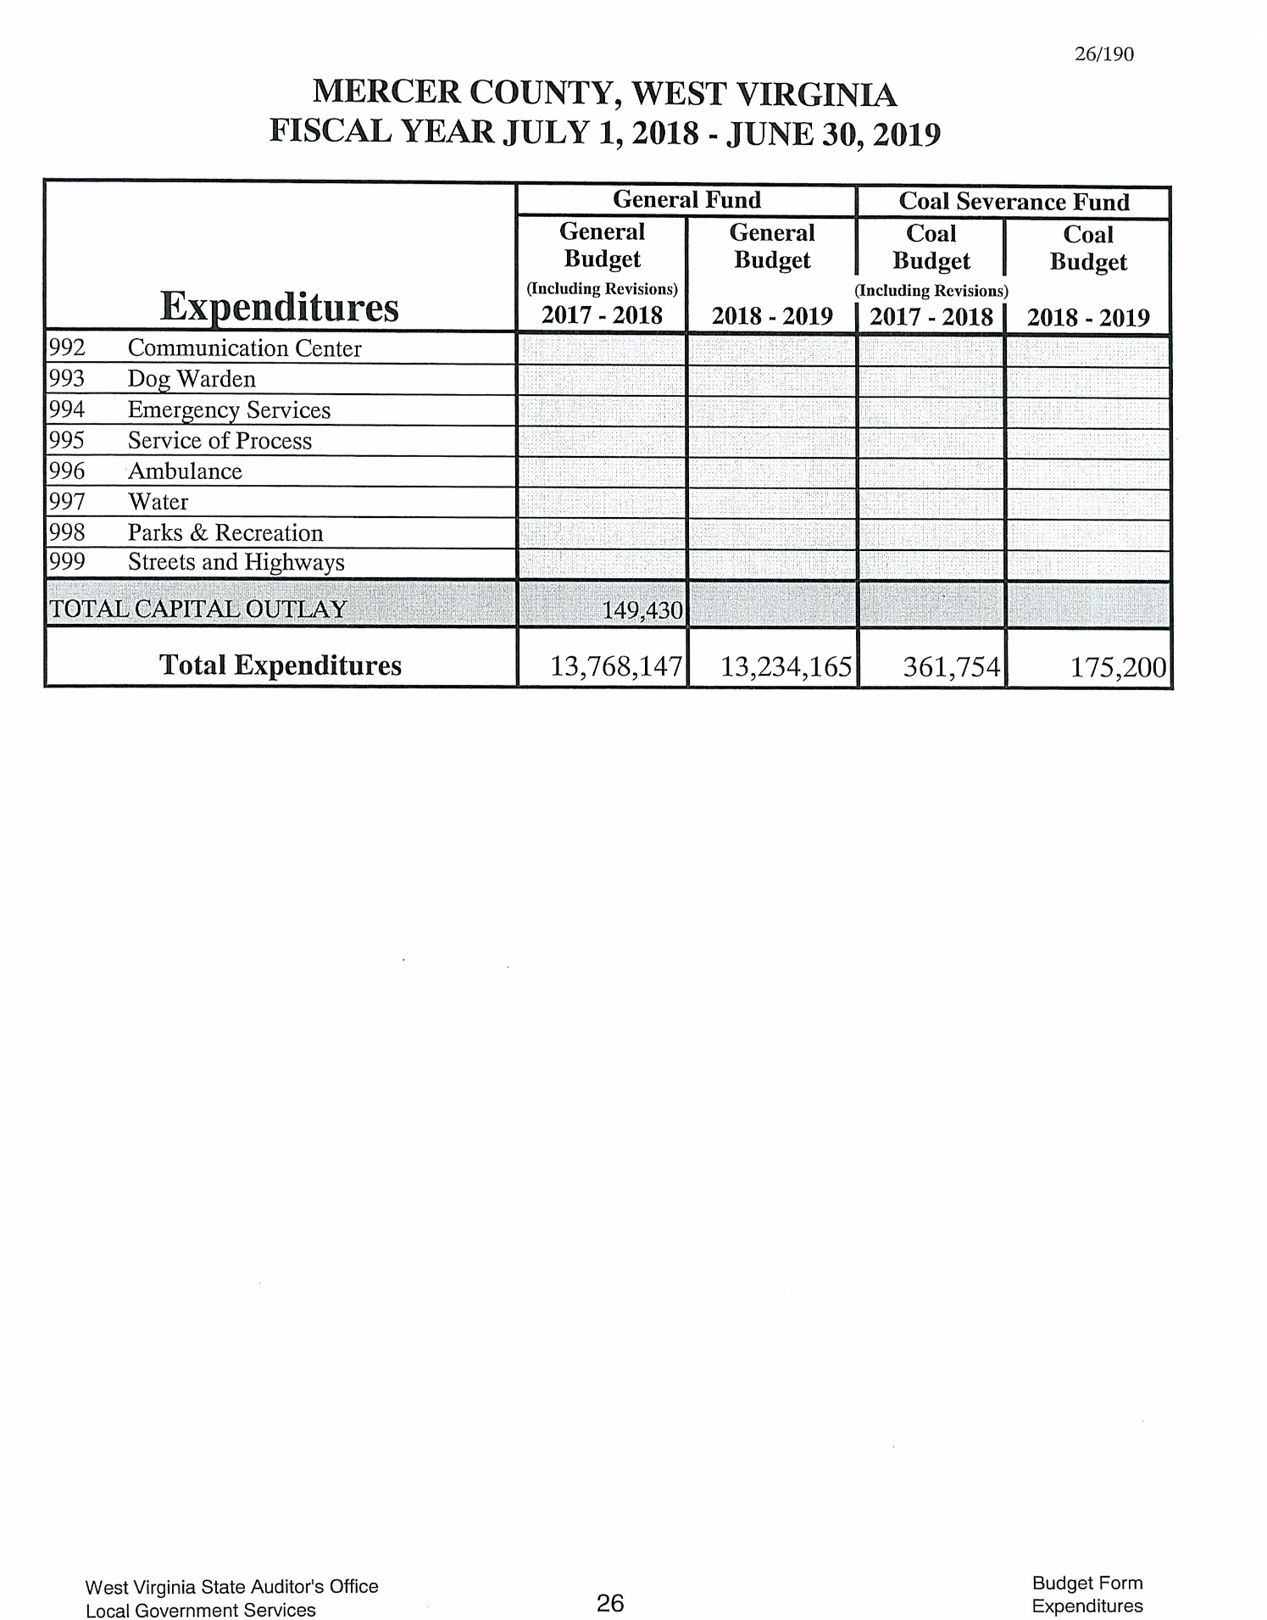

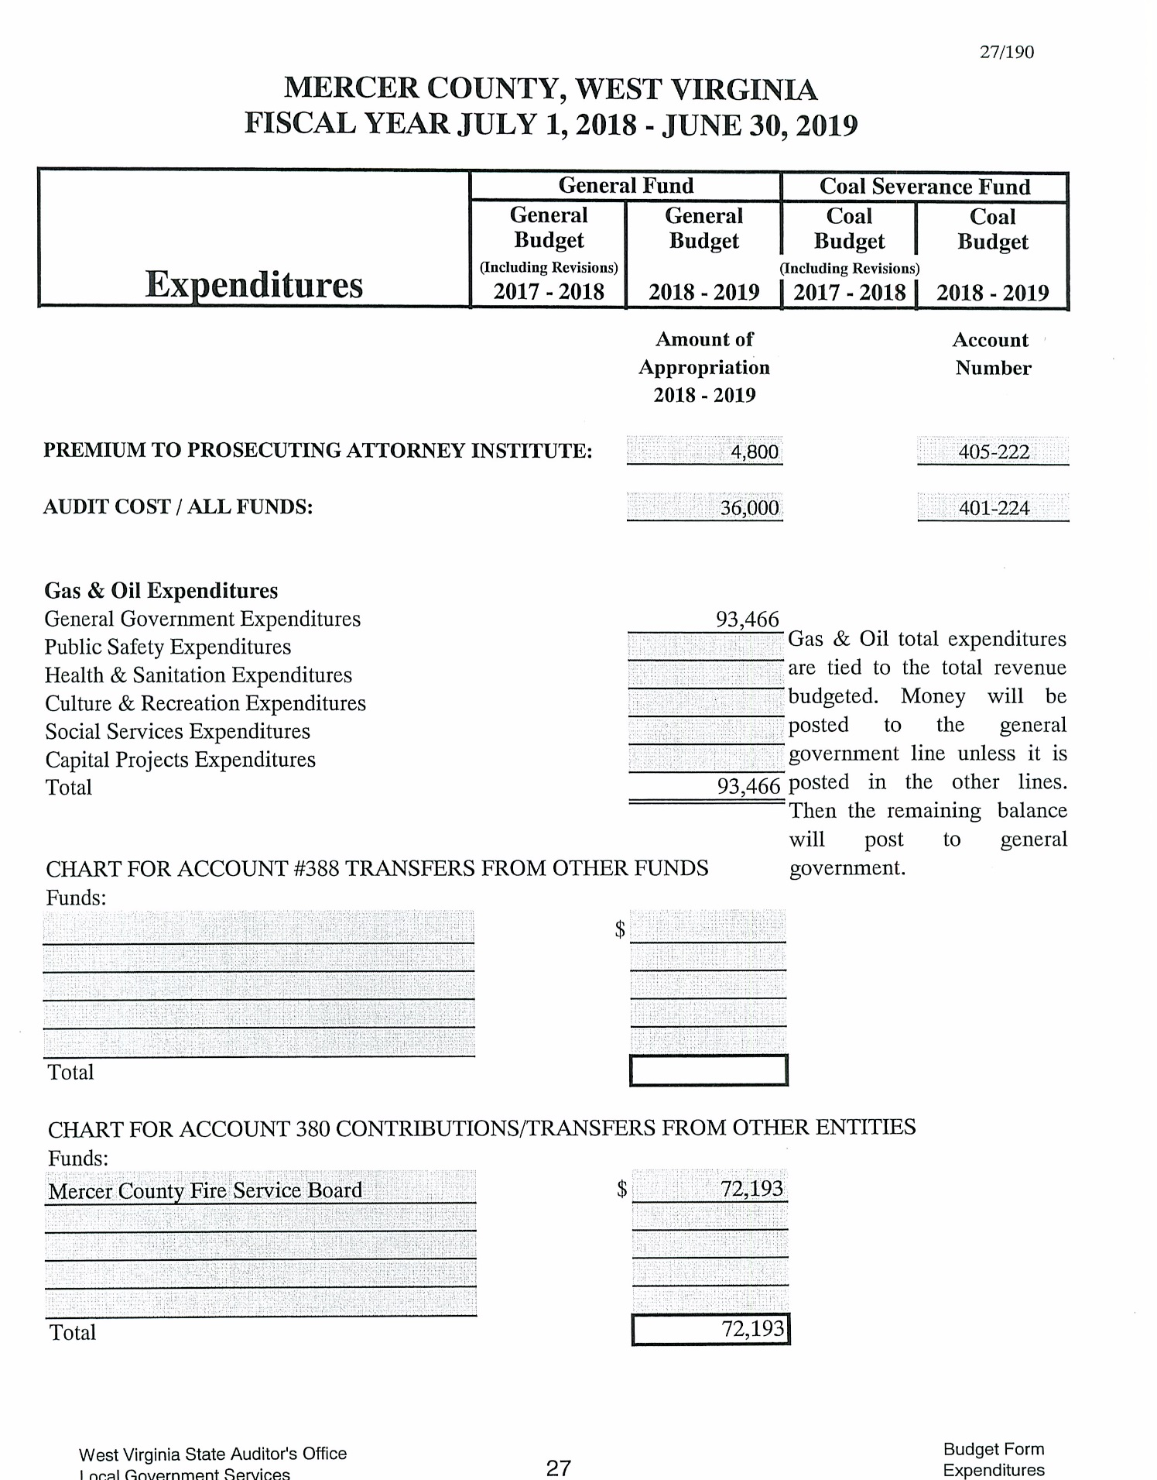

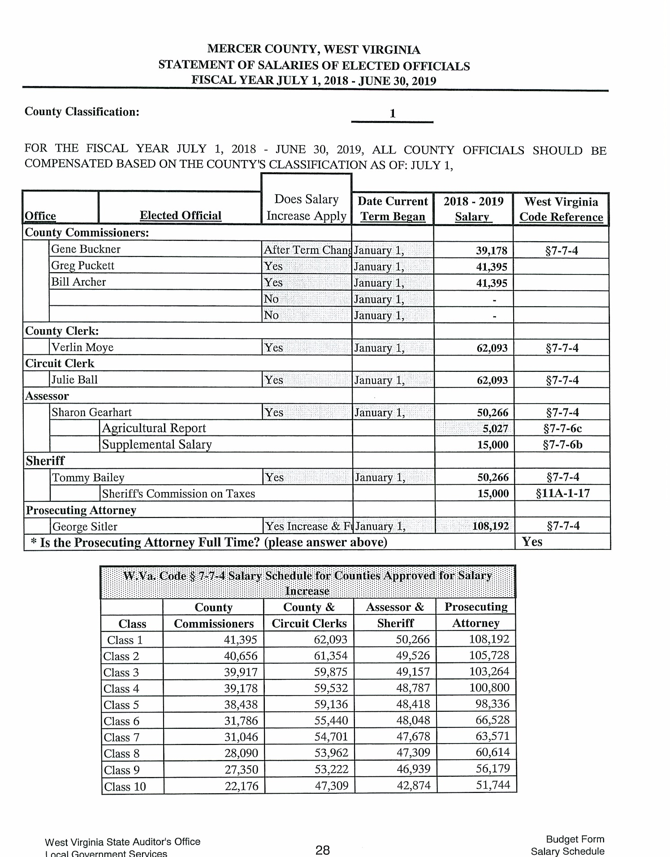

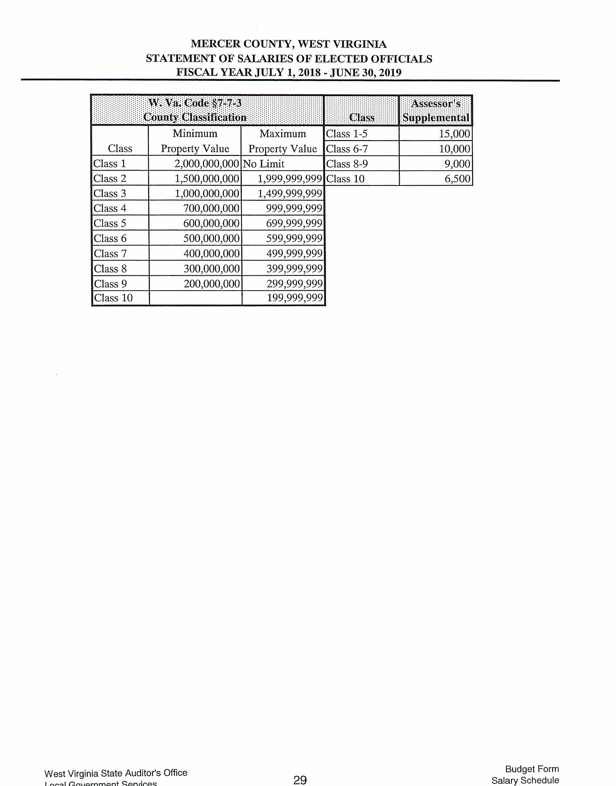

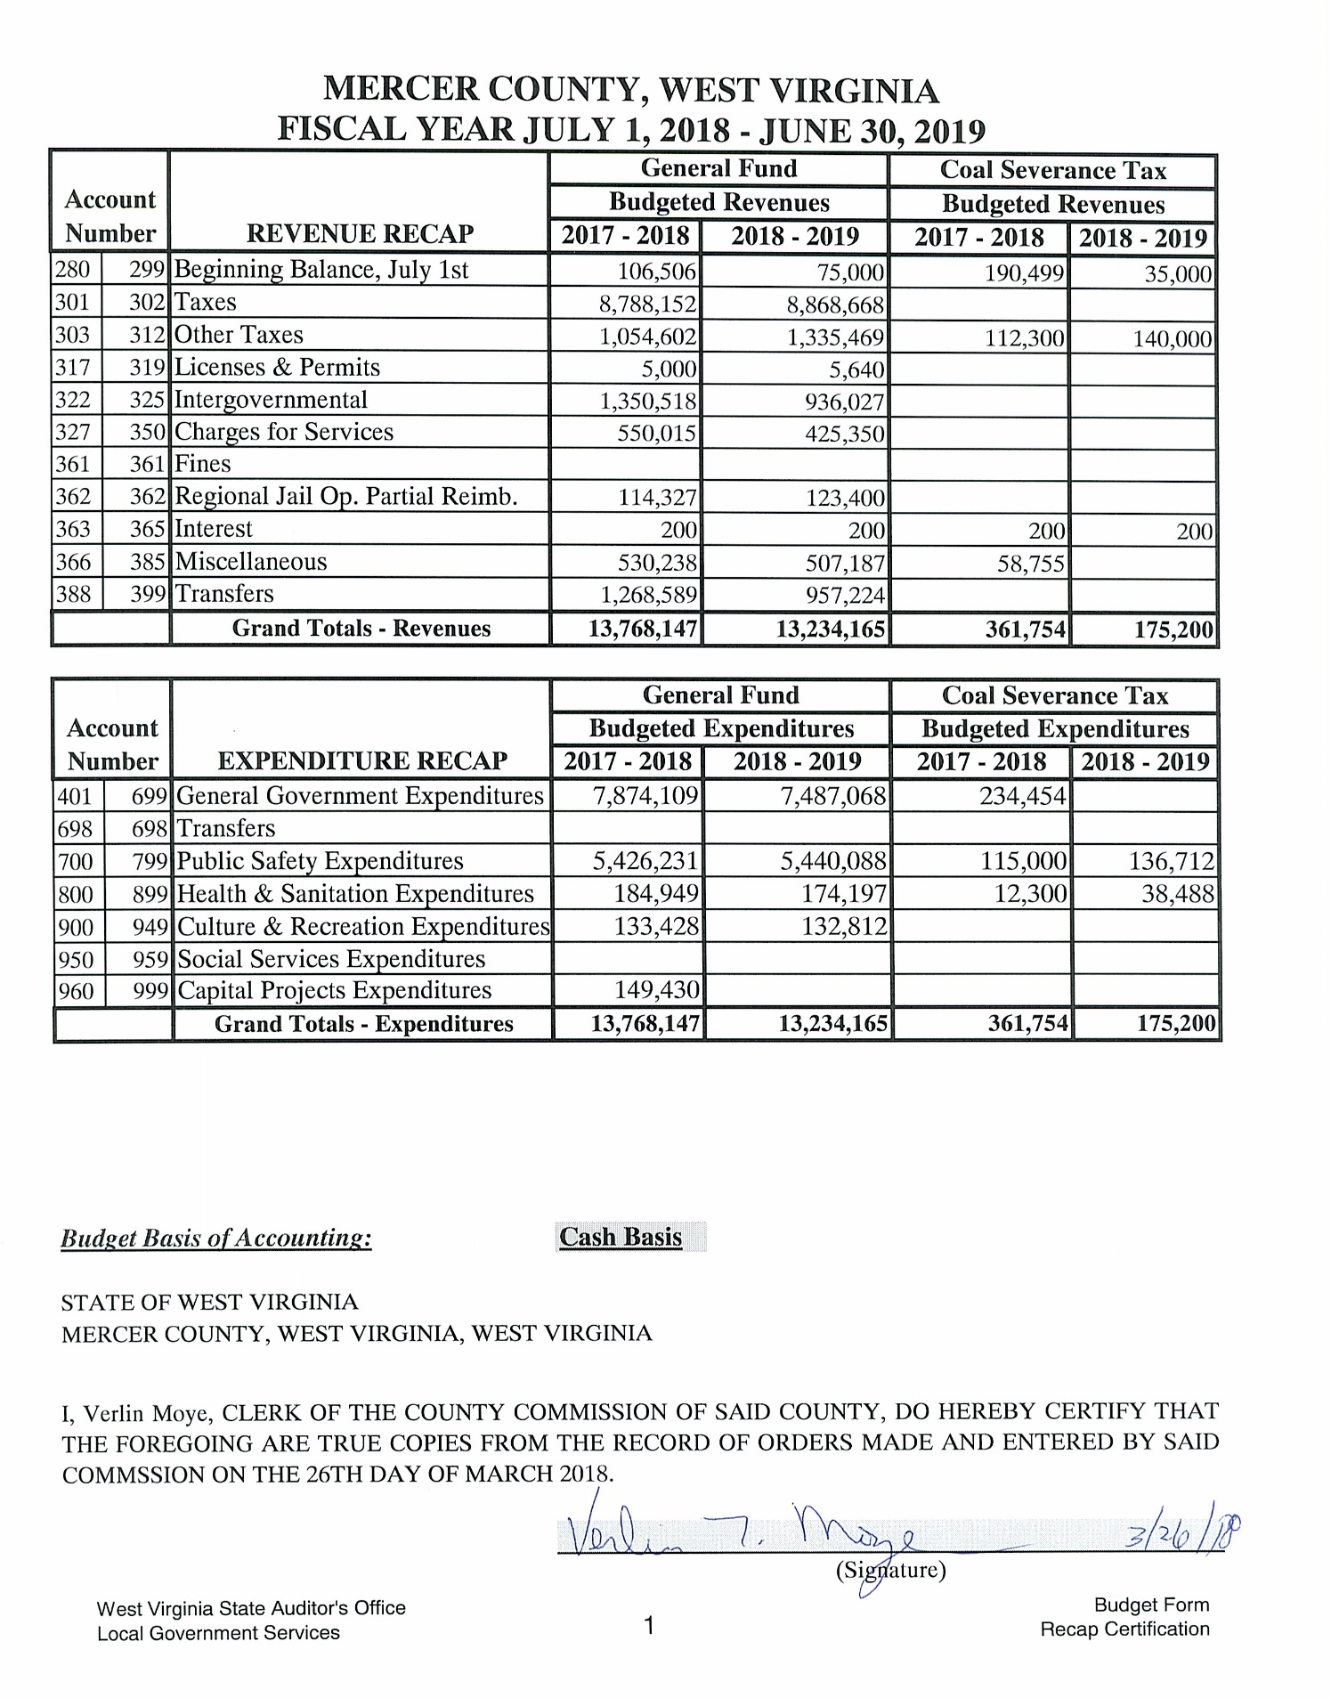

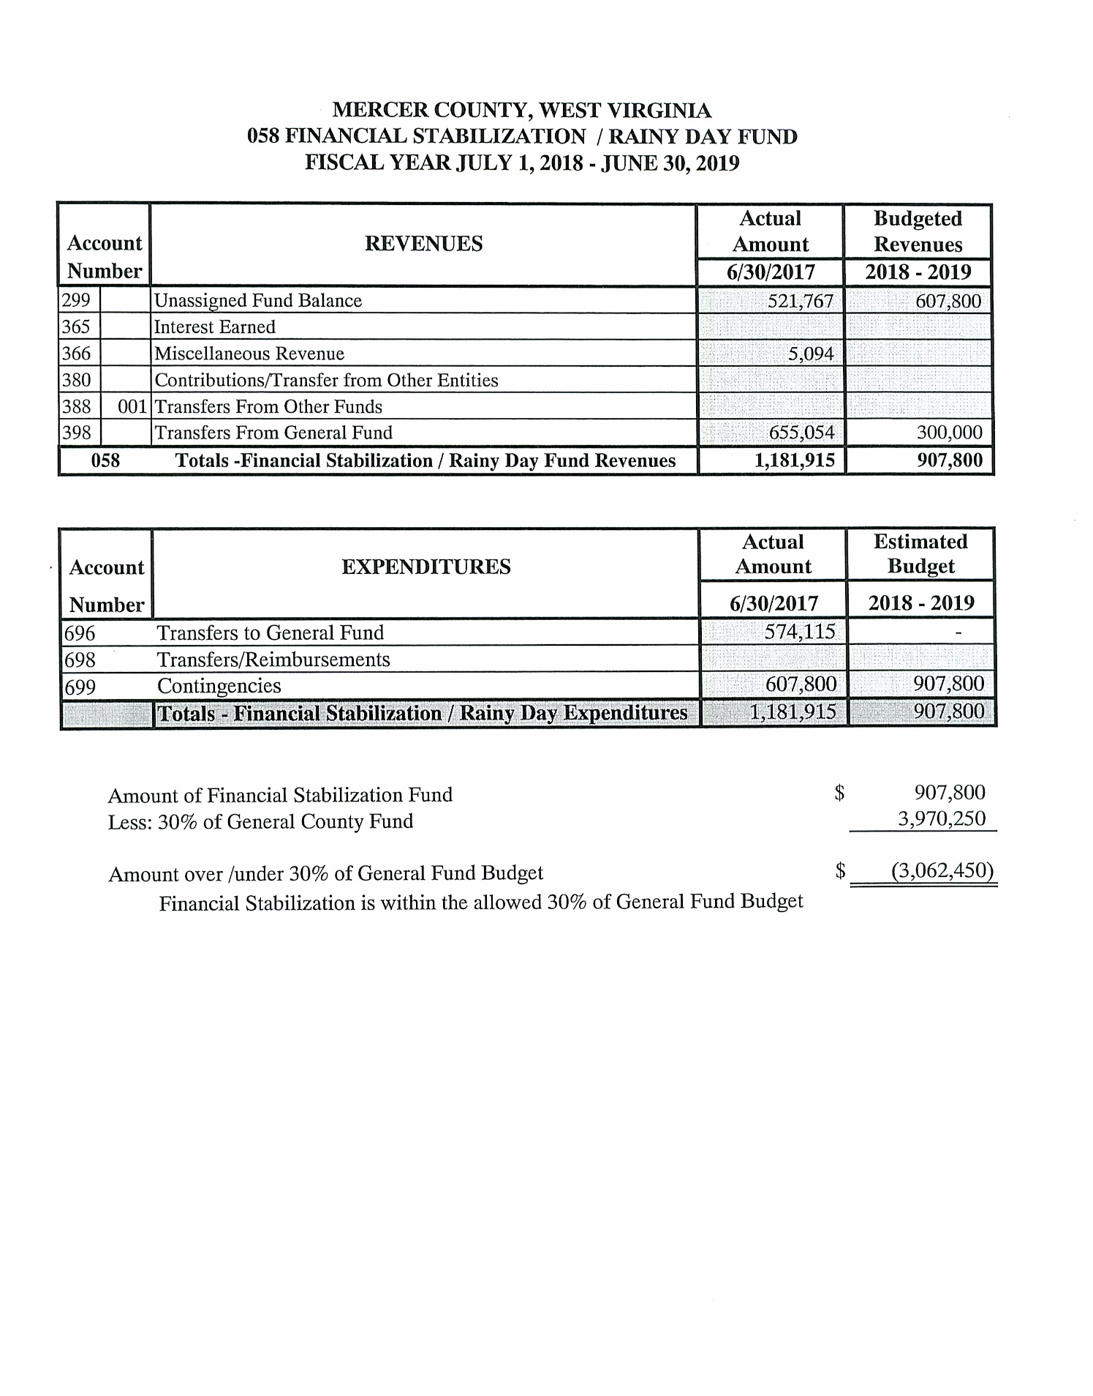

It is ordered that this Commission be and is hereby adjourned until Tuesday, April 10, 2018.
_____________________________________PRESIDENT

