WEST VIRGINIA:
At a regular session of the County Commission, held for the County of Mercer, at the Courthouse thereof, on Tuesday, October 10, 2017,
Present: Gene Buckner , President
Present: Greg Puckett, Commissioner
Present: Bill Archer, Commissioner

RE: RESOLUTION HONORING CONSTABLE JOSEPH H. DAVIDSON
This day on motion of Bill Archer, Commissioner, seconded by Greg Puckett, Commissioner, the Commission voted unanimously to approve a Memorial Resolution Honoring Constable Joseph H. Davidson. The Commission presented the Resolution to Linda Patterson, Constable Davidson’s granddaughter. Bill Archer commended family members for being present along with Sgt. Joe Bowling, Virginia State Police, Sgt. Aaron Maddy, WV State Police and Lt. Carl Bowles, WV State Police.
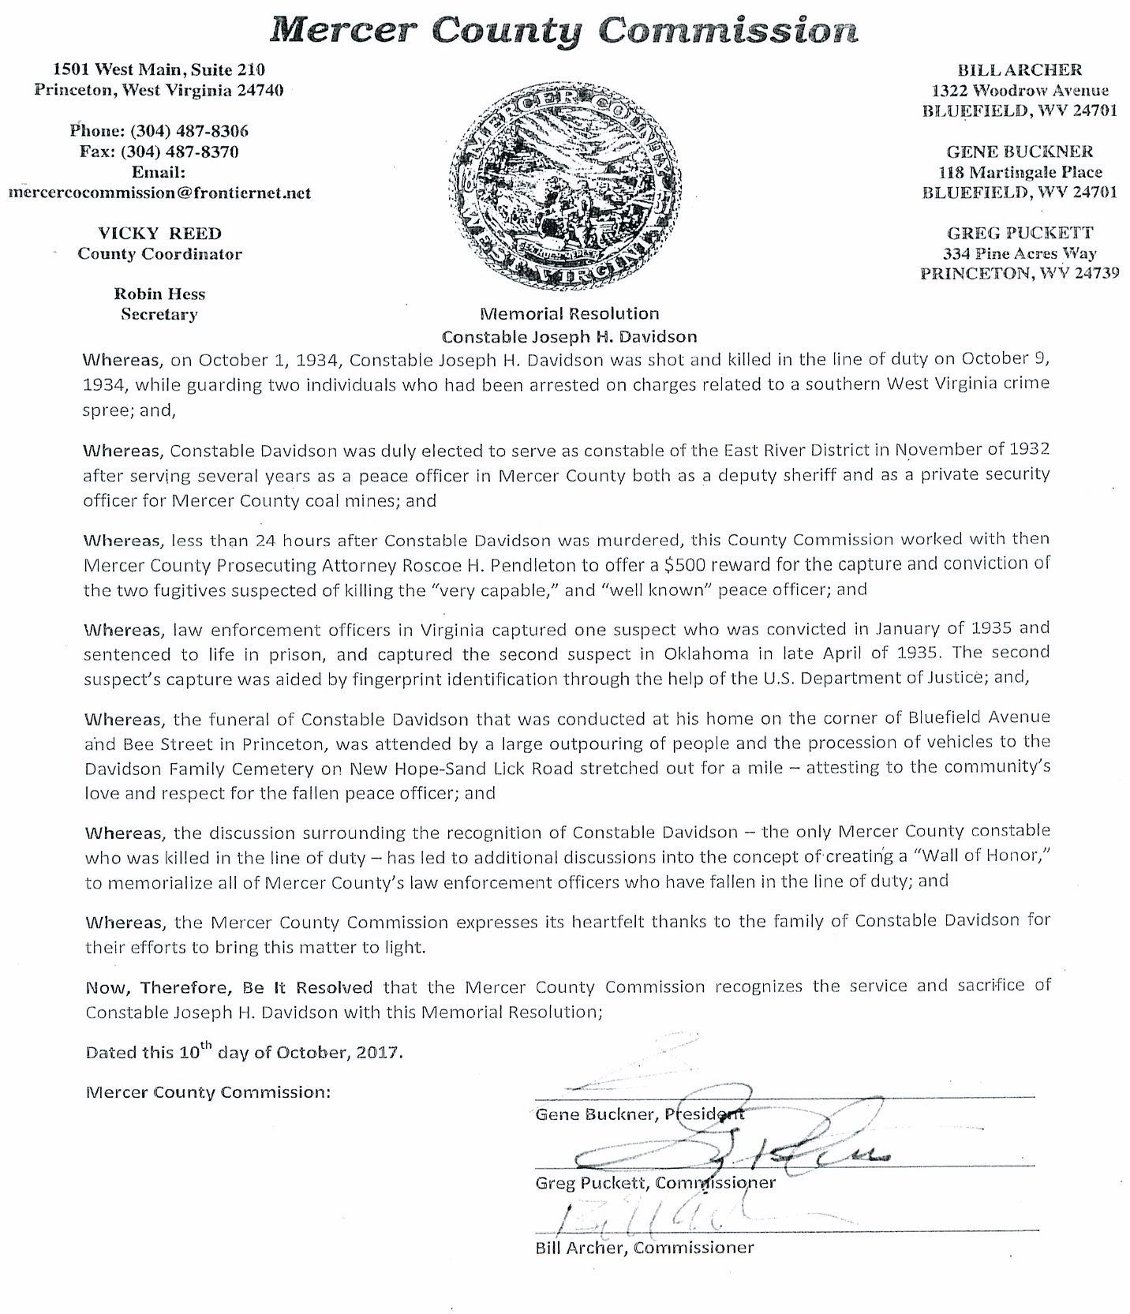

RE: OATH – MERCER COUNTY FIRE SERVICE BOARD
This day on motion of Greg Puckett, Commissioner, seconded by Bill Archer, Commissioner, the Commission voted unanimously to approve the Appointment and Oath of Office for Phillip Sigmon to serve as Board Member for the Mercer County Fire Service Board. His term will expire on June 30, 2020.

RE: OATH – MERCER COUNTY RECYCLING PROGRAM
This day on motion of Bill Archer, Commissioner, seconded by Greg Puckett, Commissioner, the Commission voted unanimously to approve the Employment and Oath of Office for Eugene V. Redden, III to serve as Full-Time Recycling Coordinator.

RE: OATH – CUMBERLAND ROAD PUBLIC SERVICE DISTRICT
This day on motion of Bill Archer, Commissioner, seconded by Greg Puckett, Commissioner, the Commission voted unanimously to approve the Appointment and Oath of Office for Eugene Penland to serve as Board Member for the Cumberland Road Public Service District. His term will expire on July 14, 2020.

RE: OATH – MERCER DAY REPORT CENTER
This day on motion of Greg Puckett, Commissioner, seconded by Bill Archer, Commissioner, the Commission voted unanimously to approve the Employment and Oath of Office for Shannon Smith to serve as Full-Time Community Service Supervisor for the Mercer Day Report Center.

RE: OATH – MERCER COUNTY SHERIFF’S DEPARTMENT
This day on motion of Gene Buckner, Commissioner, seconded by Bill Archer, Commissioner, the Commission voted unanimously to table the Employment and Oath of Office for Christopher Skaggs to serve as Security Officer for the Mercer County Sheriff’s Department.

RE: MERCER COUNTY DEVELOPMENT AUTHORITY MEMBERS
This day on motion of Bill Archer, Commissioner, seconded by Greg Puckett, Commissioner, the Commission voted unanimously to approve the following member appointments and re-appointments:
One Year Term-Ending August 1, 2018
Gene Buckner, Mercer County Commission
Ron Martin, City of Bluefield
Dewey Russell, City of Princeton
Louise Stoker, Town of Bramwell
Shane Carosi, BB&T

RE: MERCER COUNTY DEVELOPMENT AUTHORITY MEMBERS

This day on motion of Greg Puckett, Commissioner, seconded by Bill Archer, Commissioner, the Commission voted unanimously to approve the following member appointments and re-appointments:
Three Year Terms-Ending August 1, 2020
Ronn Robinson, Appalachian Power
Mori Williams, New Peoples Bank
Dr. Deborah Akers, Mercer County Schools
Frank Brady, WVVA Television
Robert Farley, PMCCC
Dr. Marsha Krotseng, Blfd State College
W. Larry Ratliff, First Community Bank

RE: MERCER COUNTY DEVELOPMENT AUTHORITY OFFICERS

This day on motion of Bill Archer, Commissioner, seconded by Greg Puckett, Commissioner, the Commission voted unanimously to approve the following officer re-appointments:
Officers-Term-Ending August 1, 2018
Frank Brady, Chairman
Bill Hopkins, Vice-Chairman
Gene Buckner, Treasurer
Janet Bailey, Secretary

RE: DRAWDOWN – MERCER/SUMMERS IV-B ELGOOD WATER PROJECT

This day on motion of Greg Puckett, Commissioner, seconded by Bill Archer, Commissioner, the Commission voted unanimously to accept Drawdown #27 in the amount of $277,194.65 for the Mercer/Summers IV-B Elgood Water Line Extension Project.

RE: GRANT – WV RECORDS MANAGEMENT & PRESERVATION GRANT
This day on motion of Bill Archer, Commissioner, seconded by Greg Puckett, Commissioner, the Commission voted unanimously to approve a WV Records Management & Preservation Grant Application in the amount of $25,750 for the County Clerk’s Office and $24,863.85 for the Circuit Clerk’s Office.

RE: AGREEMENT – TYLER TECHNOLOGIES
This day on motion of Bill Archer, Commissioner, seconded by Greg Puckett, Commissioner, the commission voted unanimously to approve the maintenance and support agreement with Tyler Technologies for the Sheriff’s Department. Funding in the amount of $31,582 will be taken from the Courthouse Equipment Fund.

RE: RESOLUTION – ROADS TO PROSPERITY ROAD BOND AGREEMENT
This day on motion of Greg Puckett, Commissioner, seconded by Bill Archer, Commissioner, the commission voted unanimously to accept the Resolution of Support for the Roads to Prosperity Road Bond Agreement dated September 21, 2017.

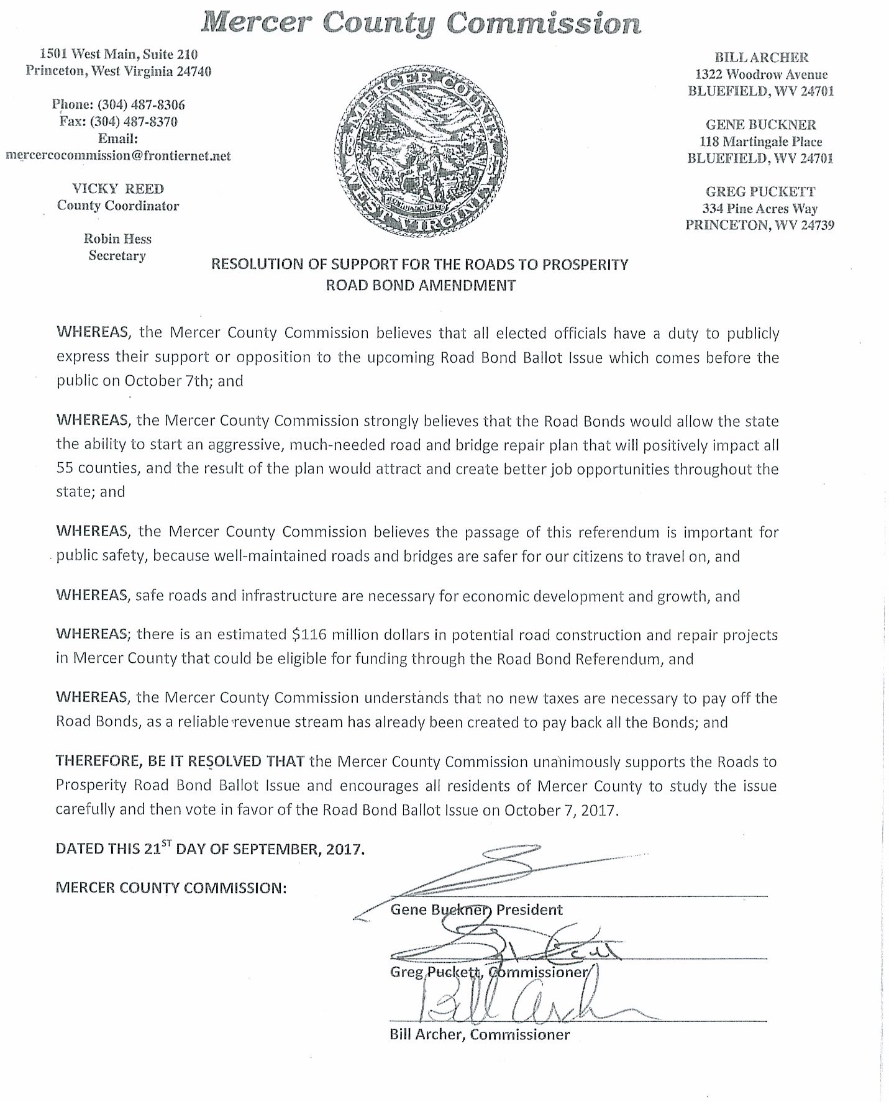

RE: GRANT – WV DIVISION OF HOMELAND SECURITY AND EMERGENCY MANAGEMENT

This day on motion of Greg Puckett, Commissioner, seconded by Bill Archer, Commissioner, the Commission voted unanimously to accept the WV Division of Homeland Security and Emergency Management Grant award in the amount of $21,351 for salary and wages for Tim Farley, Emergency Management Director.

RE: FUNDING REQUEST – PULLIN, FOWLER, FLANAGAN, BROWN & POE
This day on motion of Bill Archer, Commissioner, seconded by Greg Puckett, Commissioner, the commission voted unanimously to approve an invoice from Pullin, Fowler, Flanagan, Brown & Poe, PLLC for attorney fees for employment issues. Funding in the amount of $3,672.94 will be taken from the General Fund.

RE: FUNDING REQUEST – BLUEFIELD HIGH SCHOOL YEARBOOK STAFF
This day on motion of Greg Puckett, Commissioner, seconded by Bill Archer, Commissioner, the request to purchase a business advertisement in the Bluefield High School Yearbook was approved. Funding in the amount of $50 for one fourth page ad will be taken from the Video Lottery Fund. Gene Buckner opposed.

RE: FUNDING REQUEST – NATIONAL ASSOCIATION OF COUNTIES
This day on motion of Bill Archer, Commissioner, seconded by Greg Puckett, Commissioner, the commission voted unanimously to table until later in meeting.

RE: FUNDING REQUEST – MERCER COUNTY ANIMAL SHELTER
This day on motion of Bill Archer, Commissioner, seconded by Greg Puckett, Commissioner, the commission voted unanimously to accept the request from Stacey Harman to purchase 43 large and 8 small Kuranda dog beds for the Animal Shelter. Funding in the amount of $3,947.20 will be taken from the Estate Donation Fund.

RE: FUNDING REQUEST – MERCER COUNTY COMMISSION
This day on motion of Bill Archer, Commissioner, seconded by Greg Puckett, Commissioner, the commission voted unanimously to approve the purchase of a locking filing/storage cabinet for the County Commission Office. Funding in the amount of $734.98 will be taken from the General Fund.
RE: DISCUSSION – SJR 8 TAX REFORM
This day Greg Puckett, Commissioner made a statement regarding the SJR 8 Tax Reform that is being discussed in the legislature. SJR 8’s proposals will cut County revenues dramatically if enacted. No other group that is allocated funds via personal and real property taxes is losing-out but Counties, a drop from approximately 27% to 15%.
Current v. SJR8 Allocations

Current SJR 8
County 26.97% County 15%
Municip. 6.80 % Municip. 10%
Schools 65.81% Schools 65%
State .42% NEW 10%
State Equalization and Infrastructure Fund

RE: DISCUSSION – FALL KEEP MERCER CLEAN EVENT
This day Greg Puckett, Commissioner discussed the Fall Keep Mercer Clean Event planned from October 20th to November 1st. Information will be advertised on how to clean up for fall. This is the 1st fall clean up event since the Keep Mercer Clean Campaign launched 3 years ago.

RE: DISCUSSION – DELINQUENT HOTEL MOTEL TAXES
This day Tommy Bailey, Sheriff gave an update regarding delinquent Hotel Motel taxes. The Sheriff will meet with the Prosecutor to discuss a plan to make sure that all Hotel Motel tax is paid in a timely manner. Donna Lowe and Kitt McCarthy suggested revising the Hotel Motel tax form.

RE: DISCUSSION – HOTEL MOTEL TAX EXPENDITURES
This day Gene Buckner, President read a letter from George Sitler, Prosecuting Attorney regarding Hotel Motel Tax expenditures. Public comments from Gene Buckner, Bill Archer, Greg Puckett, Jamie Null, Josh Cline, Anthony Ferraraccio, Clint Ransom, Kitt McCarthy, Robert Farley, Dewey Russell, John Johnson, Eric Porterfield, Donna Lowe, and Deb McCarthy.
This day on motion of Bill Archer, Commissioner, seconded by Gene Buckner, Commissioner, the commission voted to continue doing business as is until the next budget cycle comes through the first of next year. Greg Puckett opposed.

RE: PUBLIC COMMENTS – GREG PUCKETT
This day Greg Puckett publicly thanked Tommy Bailey, Sheriff for reaching out to the WV State Police and working to resolve a situation that came up. He also thanked Sergeant Maddy with the WV State Police. Magistrate Sandra Dorsey commended all Law Enforcement for their hard work.

This day came Tri C Enterprises LLC, by representative, and moved the Commission to correct the Land Books for 2017, touching the assessment thereon against the said Tri C Enterprises LLC on Lot 31 Sec 39 Mercer (Comm), Princeton District, County of Mercer, State of West Virginia. Prosecuting Attorney waiving notice thereto.
After hearing all the evidence in the case and it appearing to the Commission that the property assessed for $21,900 class 4 – should be assessed for $14,280 class 4. It is therefore ordered that Tri C Enterprises LLC be exonerated from the payment of taxes, or if the taxes have been paid, shall be refunded by the Sheriff of Mercer County on such erroneous assessment.
Amount of Exoneration $211.53

This day came Rita Thompson Kirby, by representative, and moved the Commission to correct the Land Books for 2015, touching the assessment thereon against the said Rita Thompson Kirby on Pt Lot 3-4 B College, Princeton District, County of Mercer, State of West Virginia. Prosecuting Attorney waiving notice thereto.
After hearing all the evidence in the case and it appearing to the Commission that the property assessed for $69,240 class 4 – should be assessed for $69,240 class 2. It is therefore ordered that Rita Thompson Kirby be exonerated from the payment of taxes, or if the taxes have been paid, shall be refunded by the Sheriff of Mercer County on such erroneous assessment.
Amount of Exoneration $961.05

This day came Rita Thompson Kirby, by representative, and moved the Commission to correct the Land Books for 2016, touching the assessment thereon against the said Rita Thompson Kirby on Pt Lot 3-4 B College, Princeton District, County of Mercer, State of West Virginia. Prosecuting Attorney waiving notice thereto.
After hearing all the evidence in the case and it appearing to the Commission that the property assessed for $72,300 class 4 – should be assessed for $72,300 class 2. It is therefore ordered that Rita Thompson Kirby be exonerated from the payment of taxes, or if the taxes have been paid, shall be refunded by the Sheriff of Mercer County on such erroneous assessment.
Amount of Exoneration $1,003.53

This day came Rita Thompson Kirby, by representative, and moved the Commission to correct the Land Books for 2017, touching the assessment thereon against the said Rita Thompson Kirby on Pt Lot 3-4 B College, Princeton District, County of Mercer, State of West Virginia. Prosecuting Attorney waiving notice thereto.
After hearing all the evidence in the case and it appearing to the Commission that the property assessed for $74,040 class 4 – should be assessed for $74,040 class 2. It is therefore ordered that Rita Thompson Kirby be exonerated from the payment of taxes, or if the taxes have been paid, shall be refunded by the Sheriff of Mercer County on such erroneous assessment.
Amount of Exoneration $1,027.68

This day came William W. Jr./Pat Slade, by representative, and moved the Commission to correct the Personal Property Books for 2017, touching the assessment thereon against the said William W. Jr./Pat Slade on a 2015 Mercedes, Beaver Pond District, County of Mercer, State of West Virginia. Prosecuting Attorney waiving notice thereto.
After hearing all the evidence in the case and it appearing to the Commission that the taxpayer turned in and paid on a 2015 Mercedes assessed for $38,835 class 3. Vehicle is leased and taxes are paid through lease. It is therefore ordered that William W. Jr./Pat Slade be exonerated from the payment of taxes, or if the taxes have been paid, shall be refunded by the Sheriff of Mercer County on such erroneous assessment.
Amount of Exoneration $861.78

This day came Susan Hill, by representative, and moved the Commission to correct the Personal Property Books for 2017, touching the assessment thereon against the said Susan Hill on a 2014 GMC, Bluefield District, County of Mercer, State of West Virginia. Prosecuting Attorney waiving notice thereto.
After hearing all the evidence in the case and it appearing to the Commission that the taxpayer was double assessed on 2014 GMC assessed for $18,570 class 4. It is therefore ordered that Susan Hill be exonerated from the payment of taxes, or if the taxes have been paid, shall be refunded by the Sheriff of Mercer County on such erroneous assessment.
Amount of Exoneration $635.26

PETITION FOR CANCELLATION OF ERRONEOUS CHARGES
DATE 9/5/2017
Tax Year 2017
East River District

TICKET # NAME REASON AMOUNT
706747 Appalachian Properties Taxpayer turned in wrong $ 2,653.26
Information.
708248 Thomas E. Harman Reconstructed vehicle. 201.78

Tax Year 2017
Beaver Pond District

TICKET # NAME REASON AMOUNT
701013 Miranda Cline Double assessed on MH. $ 64.18
700982 Andrew L. Clark III Did not own MH 7/1/16. 24.32

Tax Year 2015
Beaver Pond District

TICKET # NAME REASON AMOUNT
504699 Amanda E. Webster Taxpayer paid a supplement $ 18.44
Ticket instead of regular
Ticket.

This day the flowing accounts were presented against the County of Mercer, and the Commission having examined each and all of them, doth allow payment from the different accounts, check numbers listed below:

GENERAL COUNTY - Check #69058-69159
COAL SEVERANCE - Check #3277-3554
JUSTICE FINES - Check #5313
EMERGENCY 911 - Check #4262
HOME CONFINEMENT - Check #2298-2303
HOTEL MOTEL - Check #3615-3623
K-9 FUND - Check #1478-1480
COURTHOUSE EQUIPMENT - Check #737
COURTHOUSE ANNEX - Check #1445-1450
VIDEO LOTTERY - Check #1254-1255
MCDRC FEES - Check #4607-4623
ASSESSOR REAPPRAISAL - Check #5989-6002
DRUG FORFEITURE - Check #191-193
SHERIFF DRUG FUND - Check #1046
TEEN COURT - Check #198
ANIMAL SHELTER EST. DONATION - Check #1004
DEPUTY SHERIFF RETIREMENT - Check #248

RE: EXECUTIVE SESSION
This day on motion of Greg Puckett, Commissioner, seconded by Bill Archer, Commissioner, the Commission voted unanimously to go into executive session. On motion of Bill Archer, Commissioner, seconded by Greg Puckett, Commissioner, the Commission voted unanimously to come out of executive session and go back into regular session. No votes were taken during the executive session.

RE: APPROVAL – NATIONAL ASSOCIATION OF COUNTIES
This day on motion of Bill Archer, Commissioner, seconded by Greg Puckett, Commissioner, the commission voted unanimously to approve the National Association of Counties Membership. Funding in the amount of $1,245 will be taken from the General Fund.

It is ordered that this Commission be and is hereby adjourned until Tuesday, October 24, 2017.
_____________________________________PRESIDENT

