COUNTY COMMISSION MEETING – TUESDAY, SEPTEMBER 12, 2017 – 10:00 A.M.

AGENDA: OPEN WITH PRAYER
PLEDGE OF ALLEGIANCE
MINUTES OF PREVIOUS MEETING

RECOGNITION - Resolution Honoring Charles A. Peters
Bill Archer, Commissioner

- Mercer County Heritage Art Contest
Winners-Bill Archer, Commissioner

APPOINTMENTS/REAPPOINTMENTS
OATHS OF OFFICE - Mercer County Fire Service Board
Appointment & Oath of Office
Phillip Sigmon, Board Member
Term: 7/1/2017 to 6/30/2020

- Mercer County Planning Commission
Reappointments
One Year Terms-10/1/2017 to 9/30/2018
Jamie Null
Will Stafford
Robert Farley
Two Year Terms-10/1-2017 to 9/30/2019
Janet Bailey
Chandler Swope
Bill Hopkins
Skip Crane

CONTRACTS
AND RESOLUTIONS - WV Division of Highways
Presentation-Governor Justice’s Roads to Prosperity Proposal
Joseph Pack, Assistant District Engineer

- West Virginia Conservation Agency
Agreement to Perform Stream Restoration, Bank Stabilization, and Blockage Removal
Brian Farkas, Executive Director

- Hatfield-McCoy Trails
Request for ATV Usage on State Roads
Jeff Lusk, Executive Director

- Mountain RC&D
Devon Duncan

- Development Authority of Mercer County
Resolution-Mercer County’s Lead Economic Development Organization
Janet Bailey, Executive Director

- Groundwater Restrictions
George Robertson, Senior Project Manager
CARDNO

- Mercer County Convention & Visitors Bureau-Annual Report
Jamie Null, Executive Director
Hotel-Motel Tax Advisory Board Members

- FY 2017/2018 Budget Revision #2
Verlin Moye, County Clerk

- Approval of Pollworker List for
Special Election-October 7, 2017
Verlin Moye, County Clerk

- WV Division of Culture & History
State Historic Preservation (SHPO)
Grant Contract & Covenant ($7,316)
Vicky Reed, County Administrator

- City of Bluefield
FY 2017 Edward Byrne Justice Assistance Grant-Memorandum of Understanding
Gene Buckner, President

FUNDING REQUESTS - Mercer County Emergency Management
Hazardous Material Spill Equipment
Tim Farley, Director

- City of Bluefield
Replacement of Flags
Marie Blackwell, City Ambassador

- Greater Bluefield Chamber of Commerce
22nd Biennial Bluefield Coal Show
Josh Cline, President/CEO

- Chuck Mathena Center
Candace Wilson, Executive Director

- Princeton-Mercer County Chamber of Commerce-12th Annual Princeton Autumnfest
Robert Farley, President/CEO

- Bluewell Improvement Association
Purchase of Electronic Sign
Skip Crane, President

- Cox Security Services
Purchase of DVR for Courthouse ($2599)
Rack Mount for Annex ($1374)

- Dunford Roofing, Inc.-Roof Repairs
Day Report Center ($6,350)
Judicial Annex ($4,900)

- Mercer County Sheriff’s Department
Purchase of Computer for Tax Office
Tommy Bailey, Sheriff

- Mercer County Adult Probation
Purchase of Work Table
Greg Arnold, Chief Probation Officer

DISCUSSION - Bluestone Watershed Association
History of Snidow Site, Mercer County
Bill Archer, Commissioner

- Mercer County Airport Authority
Letters of Interest for Vacant Seat on Board of Directors-Bill Archer, Commissioner

- Hurricane Harvey
Recognition of Organizations
Providing Assistance
Bill Archer, Commissioner

- Glenwood Recreation Park Upgrades
Purchase of New Sliding Board
Purchase of Canoes/Kayaks
Signage for Walking Trails
Greg Puckett, Commissioner

- Recognition of Makos Swim Team, Lemonade Days, Blues Festival
Gene Buckner, President

ESTATES - Glenda F. Bradley

- Ruby D. Brinkley

- Danny R. Catron

- Plez Robert Hubbard

- Brenda Lawrence

- Pauline Lowe

- Dona M. Sinclair

- Orangie Strain

- Leona Imogene Thompson

- Dewayne Vass

PUBLIC COMMENTS

EXECUTIVE SESSION

COMMISSION TO APPROVE THE FOLLOWING:
- Invoices
- Settlements
- Exonerations
- List of Approved Estates for July 2017

WEST VIRGINIA:
At a regular session of the County Commission, held for the County of Mercer, at the Courthouse thereof, on Tuesday, September 12, 2017,
Present: Gene Buckner , President
Present: Greg Puckett, Commissioner
Present: Bill Archer, Commissioner

RE: RESOLUTION – DEVELOPMENT AUTHORITY
This day on motion of Greg Puckett, Commissioner, seconded by Bill Archer, Commissioner, the Commission voted unanimously to approve a Resolution Honoring Charles A. Peters.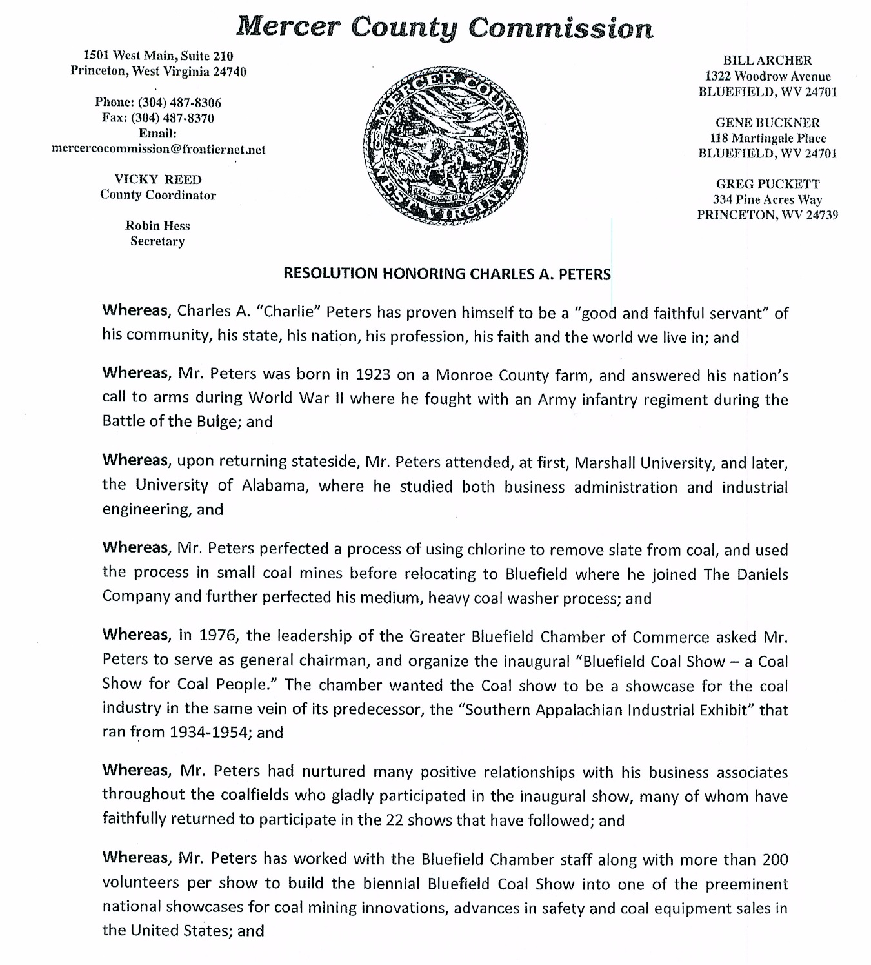

RE: FUNDING REQUEST – GREATER BLUEFIELD CHAMBER OF COMMERCE

This day on motion of Greg Puckett, Commissioner, seconded by Bill Archer, Commissioner, the Commission voted unanimously to approve a funding request from Joshua Cline, President/CEO of the Greater Bluefield Chamber of Commerce. Funding in the amount of $5,000 will be taken from the Hotel Motel fund for the 22nd Biennial Bluefield Coal Show.

RE: FUNDING REQUEST – PRINCETON-MERCER COUNTY CHAMBER OF COMMERCE

This day on motion of Bill Archer, Commissioner, seconded by Greg Puckett, Commissioner, the Commission voted unanimously to approve a funding request from Robert Farley, President & CEO of the Princeton-Mercer County Chamber of Commerce. Funding in the amount of $2,500 will be taken from the Hotel Motel fund for the 12th Annual Princeton AutumnFest.

RE: RECOGNITION - MERCER COUNTY HERITAGE ART CONTEST
This day Bill Archer, Commissioner, recognized the winners of Mercer County Heritage Art Contest that was held at the Mercer County Fair on August 4th & 5th. Karen Henkes and Jean White unveiled the artwork on display in the County Commission Courtroom.
Winners: Karen Henkes “Revitalizing a County”
Karen Henkes “Weathering the Storm”
Kerri Boardwine “Pinnacle”
Jean White “A Look at the Past”

RE: OATH – MERCER COUNTY FIRE SERVICE BOARD
This day the Appointment and Oath of Office for Phillip Sigmon to serve as Board Member for the Mercer County Fire Service Board was tabled.

RE: REAPPOINTMENT – MERCER COUNTY PLANNING COMMISSION
This day on motion of Greg Puckett, Commissioner, seconded by Bill Archer, Commissioner, the Commission voted unanimously to approve the following Mercer County Planning Commission member re-appointments:
One Year Terms-10/1/17 to 09/30/18
Jamie Null
Will Stafford
Robert Farley

Two Year Terms-10/1/17 to 09/30/19
Janet Bailey
Chandler Swope
Bill Hopkins
Skip Crane

RE: PRESENTATION – WV DIVISION OF HIGHWAYS

This day a presentation for Governor Justice’s Roads to Prosperity Proposal was tabled. Robert Farley commented that a meeting will be held on October 2nd from 6:00-8:00p.m. at the Mercer County Technical Education Center to answer any questions regarding the bond proposal vote that occurs on October 7th.

RE: WEST VIRGINIA CONSERVATION AGENCY
This day an agreement between the West Virginia Conservation Agency and the Mercer County Commission was tabled.

RE: APPROVAL – ATV ACCESS – MATOAKA AREA
This day on motion of Greg Puckett, Commissioner, seconded by Bill Archer, Commissioner, the Commission voted unanimously to approve ATV access 1.2 miles of 10/4, 2.3 miles of 11/2, 3.1 miles of 11/4, 285’ of 11 and 1.8 miles of 11/6 in the Matoaka area with the stipulation that we work with the Department of Highways to make sure these areas are marked to let travelers know that the road is shared with ATV’s.

RE: MOUNTAIN RC & D
This day Devon Duncan, secretary and Quincy Adams, County Agent for Mountain Resource, Conservation, and Development appeared before the County Commission to discuss potential funding streams with an annual $1,000 membership. They discussed several projects they provided funding for and are interested in helping with a project along the Bluestone River.

RE: FUNDING REQUEST – CITY OF BLUEFIELD
This day on motion of Greg Puckett, Commissioner, seconded by Bill Archer, Commissioner, the Commission voted unanimously to approve a funding request from Dane Rideout, Bluefield City Manager. Funding in the amount of $1,000 will be taken from the Video Lottery fund as a match to the funds that have already been raised to help replace 150 flags the City of Bluefield displays during major holidays.

RE: RESOLUTION – DEVELOPMENT AUTHORITY OF MERCER COUNTY
This day on motion of Greg Puckett, Commissioner, seconded by Bill Archer, Commissioner, the Commission voted unanimously to accept the Resolution recognizing the Development Authority of Mercer County as the county’s lead economic development organization.
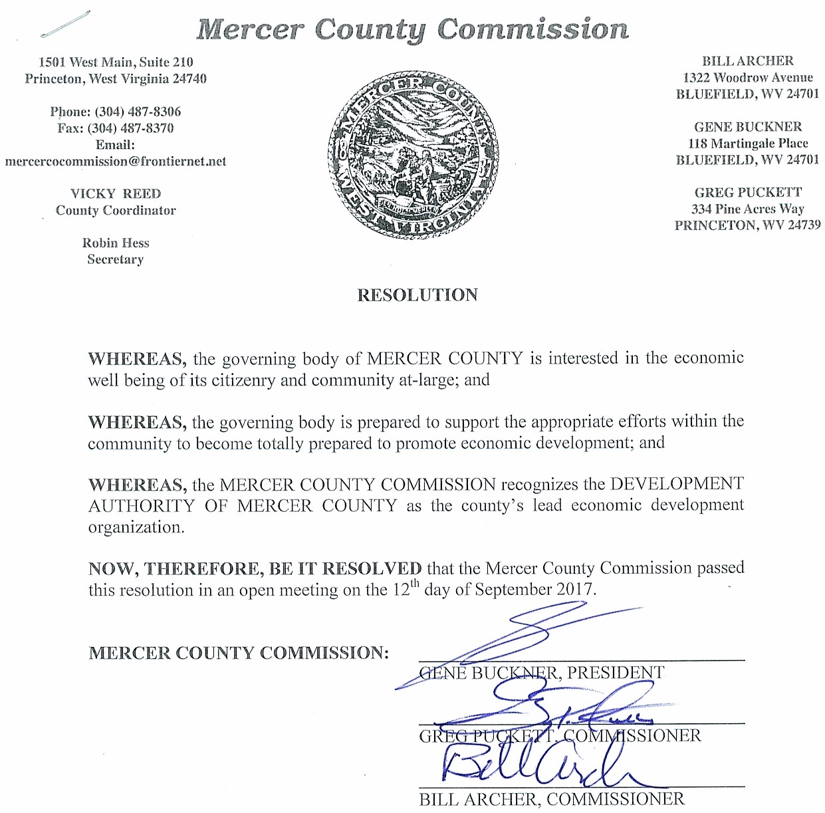

RE: GROUNDWATER RESTRICTIONS
This day George Robertson, Senior Project Manager appeared before the County Commission to request an ordinance for groundwater restriction for the southwest corner of 418½ New Hope Road. The Commission stated they will take this under consideration and ask the Prosecuting Attorney to do some research.

RE: DISCUSSION – HURRICANE HARVEY
This day Courtney Clark, Executive Director of the American Red Cross of Southeast West Virginia appeared before the Commission to discuss how the American Red Cross has provided Hurricane Harvey disaster relief.

RE: PRESENTATION – MERCER CO. CONVENTION & VISITOR’S BUREAU
This day Jamie Null, Executive Director of the Mercer County Convention & Visitor’s Bureau appeared before the Commission to present the FY 2017 Annual Lodging Tax Report. Robert Farley, President and CEO of the Princeton-Mercer County Chamber of Commerce publicly applauded Jamie Null and the CVB for a job well done.

RE: MERCER COUNTY HEALTH DEPARTMENT
This day Susan Kadar, Administrator of the Mercer County Health Department appeared before the Commission to discuss drug problems in Mercer County.

RE: APPROVAL – GENERAL COUNTY BUDGET REVISION
This day on motion of Greg Puckett, Commissioner, seconded by Bill Archer, Commissioner, the Commission voted unanimously to approve Budget Revision No. 2 for FY 2017/2018 in the amount of $248,580 for the General County Fund.

RE: ELECTION – POLL WORKER LIST SPECIAL ELECTION OCT. 7, 2017

This day on motion of Bill Archer, Commissioner, seconded by Greg Puckett, Commissioner, the Commission voted unanimously to approve the poll worker list for the Special Election to be held October 7, 2017 as presented by Verlin, Moye, County Clerk. This list is subject to corrections and additions until the election.

PollWorkerList - MERCER COUNTY
District I
D SMITH, MARY LOUISE
D SMITH, DAVID RAY
N LAMBERT, ANTHONY E
N SHREWSBURY, LEWANN MICHELLE
R SHREWSBURY, BRIANNA ASHTON
D PEERY, DEBRA J
N DAVIS, PAULINE TRESA
N DAVIS, GUY WALLACE
R MUNCEY, SANDRA
R MUNCEY, HOBERT F
D BILLINGS, DOROTHY JAN
D CHILDRESS, QUINTINA MARCHELLE
N OWENSBY, PATTI JANE
N TAYLOR, KRISTINA ANN
R DILLON, WANDA HELEN
D ROBINSON, CATRICE MONIQUE
D ROBINSON, NANCY V
D TAYLOR, DANIELLE LA SHAUNA
D WHITE, TARA NATACHIA
R PERDUE, SANDRA L
D FRENCH, DELORIS ROZZEL
D PERRY, REBECCA ROZZEL
D SIMMONS, CAROL KAY
N JARRELL, LAKEN NOEL
N PERDUE, ELIZABETH GRACE
D HAIRSTON, PHYLLIS OLIVIA
D MEDLIN, LINDA CARLINE
D WALTON, FELICA A
D WALTON, LATOYA SHERRE
N LIPFORD, JACKIE RAY
D BANE, MELINDA CECELIA
D DEWITT, MICHELLE SMITH
D THOMPSON, BONNIE, GAIL
N KINZER, DONNA, L
N TOTTEN, ERNIE TYRONE
D MORRIS, ADA BERNICE
D SAUNDERS, TINA RUTLEDGE
R BROWN, TINA R
R STAFFORD, CHRISTY ANN
R WILSON, PAMELA D
D LEWIS, REBECCA
D THOMPSON, CHARLES T
N JOHNSON, TIFFANY RENEE
N WHITTAKER, PATRICIA LOUISE
N WHITTAKER, WILLIAM R
D PRUETT, NANCY, L
D ROBINETTE, MELISSA SUELLEN
N BASHAM, CARMON DENISE
N BASHAM, AARON JAMES
N BASHAM, LYNSEY KATHLEEN
D DICKERSON, CLARA FRANCES
D MITCHEM, CANDACE LYNN
D MOORE, LEANDRA D
N WHITLOW, ROBERT BENTON
N WHITLOW, CHASTITY NICHOLE
N COMBS-HICKS, CRYSTAL RENEA
N GILLESPIE, TABITHA ANN
N KINZER, MELISSA HOPE
R CLARK, ERIN MICHELLE
R WEBB, ANDREA DAWN
D CHANDLER, JANICE R
D GIBSON, CAROLYN S
D PERRY, DONNA GAIL
D STEVENSON, SANDRA LEE
R PRUITT, JOYCE ANN
D KENNETT, HUBERT MICHAEL
N LAMBERT, JAMES ROBERT
N LAMBERT, MARIE TIFFANY
D HATFIELD, LINDA MAE
D ODLE, CONNIE SUE
N BALL, DIANNA, L
N LAFON, ETHEL MARIE
R DINGER, PATRICIA A
D JONES, LULA BELL
N SLUSS, MISTY ANN
N SLUSS, RANDY EUGENE
R FOGUS, BARBARA M
R GOODE, CHARLES JOSEPH
District II
D BESENYEI, NAOMI
D LOCKHART, BETTY QUICK
D MANN, LESLIE ERIN
N TIBBS, KATIE B
R MORAN, BARBARA A
D BALDWIN, MARY SUE
D BOOTHE, SARA ELIZABETH
N FURCHES, REGINA E
R GOODE, SYLESTER
R GOODE, SAMANTHA JO
D MEADOWS, TRINA JOY
N QUICK, JEANNE PATRICE
R GALLIMORE, TERESA E
R LANE, TAMARA MARIE
R OSBORNE, SARAH MAE
D CONNER, MELINDA SUE
D RUCKER, JOHN, O
N SIMMONS, KIMBERLY L
N WILSON, BRIDGET BEASLEY
R ROBERTSON, MICHAEL LEE
D STANLEY, SAHARA JOELLE
N PAULEY, JULIA ANN
R NESTER, HOPE REBEKAH
R WILSON, DAVID EDWIN
D HAWKINS, SUSAN L
D JACKSON, KIMBERLY EVETT
D PEDNEAU, LOUISE ELAINE
N SHUMATE, MICHELE LEE
N WHITTAKER, SHANNA S
D BALL, CARLA SUE
D BARKER, LISA ANN
D NOE, BRIONNAH MORGAN
D NOE, MICHELE SUE
D VAUGHT, RUBY JANE
D COBB, JOHNNY LEE
D PANNELL, EVELYN SWANSON
D RUCKER, MYRIA JANE
D RUCKER, JACQUELINE MILLNER
R CANTERBURY, NANCY LEE
D HARDIN, CECIL
D NELSON, PEGGY L
D STINSON, BONNIE SUE
R ELLISON, LANA L
R STINSON, CARMEN MARIE
D BROWN, THERESA DEANNA
D CLINE, REBEKAH KAYE
D MOYE, MARK, M
N DILLOW, AMBER NICOLE
N ROBINETT, SHEILA MARIE
D STAFFORD, CHRISTINE L
IND DEVOR, OPAL RAEGAN
N CARPER, THRESSA SIVELY
N DEVOR, DANIEL BRYAN
N DOWELL, RONALD WAYNE
D OSBORNE, ANNA M
D OSBORNE, EDWARD WAYNE
N BROWN, CAROLYN SUE
N CORBETT, BARBARA JO
N FARMER, LINDA S
D KIDD, DEBORAH PANASHY
D PANASHY, NANCY ANN
D PANASHY, PHYLLIS JUNE
R MILLER, HARRY WOODSON
R SHREWSBURY, GLORIA LYNN
D COMBS, WILLIAM RAY
D ELLISON, JORDAN KEITH
N COMBS, CRYSTAL MICHELLE
R MILLER, JANE WHITE
District III
D PETTREY, MICHELLE LYNN
D RACHEL, DEBORAH LYNN
N NEWBERRY, JENNIFER LYNN
R BAILEY, ANDREA COTTLE
R BECKELHIMER, REBEKAH DENISE
D ASHBY, ROBERT BERNARD
D ASHBY, GLORIA PAULETTE
N MOULDER, KAREN BOWLING
N SOWERS JR, WILLIAM BENDER
OTH SHOOK, RAMONA RUTLEDGE
D COMBS, ILETA BETH
D FITZWATER, LINDA LOU
R COPENHAVER, JACQUELINE SUSAN
R STAUFFER, ANGELA ELAINE
R STAUFFER, FRANCES ELAINE
D SOUTHERN, MINDY KAYE
D SOUTHERN, LINDA S
R LUSK, ROSALIND C
R MARTIN, AMANDA CAROL
R NICKELS, PRISCILLA DAWN
D MARTIN, THOMAS JOSEPH
D PHILLIPS, HEATHER DENISE
R COTTLE, DEBORAH ANN
R ELLISON, DANIEL GLENN
R WALKER, BARBARA LILLY
D BUCHANAN, JOAN
D RICHARDS, JANIE M
R ELLISON, NANCY CAROL WIMMER
R FARLEY, KIMBERLY J
R HUFFMAN, GAYLE WHITTAKER
D BARTON, LORI ANN
D MCKINNEY, PATRICIA A
N RICHARDS, PANSY A
N SIZEMORE, VALERIE CHRISTINE
N WHITLOW, VERA KATRINA
D LESTER, JOSEPHINE
D SMITH, WILMA HELEN
N ELLISON, AMY DENISE
N OWEN, ELIZABETH ANN
R MANN, MARY ANN
D HESS, ROBIN L
D MICHAEL, CONNIE LOU
D OFSA, SHARON, C
R SHREWSBURY, PATRICIA ANNE
D CORNER, SANDRA LEE
D JENNINGS, TERESA KAY
D WHITE, SANDRA M
N BAILEY, LINDA SUE
R COLE, PATRICIA AKERS
D THOMPSON, KATHY LYNN
D WEISS, DEBRA LYN
D WILEY, CONNIE FAY
R DOYLE, CATHERINE ANGELINE
R MCMANAWAY, ELLA JEAN
D COEBURN, DONNA S
D HATFIELD CRYSTAL GAIL
D KENNETT, VICKIE LYNN
R CECIL JR, MICHAEL R.
R CORDLE, JENNIE ANN
N NELSON, RUBY JEWELL
R BISHOP, CAROL JUNE
R BISHOP, EARNEST M
R WORLEY, GREGORY DAVID
D CONNER, BETTY RUTH
D ELLISON, WANDA M
N ELLISON, STEVEN E
N SHREWSBURY, DAVID EDWARD
R MCCLUNG, SHERRY LYNN
D BELCHER, VIRGIE MARLENE
D PEDNEAU, HOLLY RANDA
N WORLEY, CRYSTAL HALE
R GEARHEART, THERESA DIANE
R SMITH, KAREN DENISE
D COOK, BRYAN DOUGLAS
D COOK III, CHARLES (CHAD) KENNETH
N WHITTEKER, JOANN
N WHITTEKER, PAUL DAVID
R ROSE, JENNIFER LYNN
D HAZLEWOOD, KAREN LEE
N WEBSTER, JOYCE GILLIAM
R LUSK, CAROL LUCILLE
R LUSK, RUSSELL TODD
R PERDUE, NAKITA FAY
D JENNINGS, WILLIAM DUSTIN
D RICKS, FLOYD E
D THOMASON, LORA ZANE
N FARLEY, RHONDA KAY
N LOWE, LISA, KAYE
R JOHNSON, STARLENE

RE: GRANT – WV DIVISION OF CULTURE & HISTORY
This day on motion of Bill Archer, Commissioner, seconded by Greg Puckett, Commissioner, the Commission voted unanimously to approve the WV Division of Culture & History State Historic Preservation Grant Contract & Covenant in the amount of $7,316. Funding will be used to fix leaks in the basement of the Circuit Clerk’s Office. Estimated cost of said project is $14,632.

RE: MEMORANDUM OF UNDERSTANDING – CITY OF BLUEFIELD
This day on motion of Greg Puckett, Commissioner, seconded by Bill Archer, Commissioner, the Commission voted unanimously to approve the Memorandum of Understanding with the City of Bluefield for the FY 2017 Edward Bryne Memorial Justice Assistance Grant Program.

RE: FUNDING REQUEST – MERCER COUNTY EMERGENCY MANAGEMENT
This day on motion of Bill Archer, Commissioner, seconded by Greg Puckett, Commissioner, the Commission voted unanimously to approve a funding request from Tim Farley, Director of Mercer County Emergency Management for hazardous material spill equipment. Funding in the amount of $5,000 will be taken from the Video Lottery Fund.

RE: FUNDING REQUEST – CHUCK MATHENA CENTER
This day on motion of Greg Puckett, Commissioner, seconded by Bill Archer, Commissioner, the Commission voted unanimously to approve a funding request from Candace Wilson, Executive Director of the Chuck Mathena Center. Funding in the amount of $5,000 will be taken from the Hotel Motel Fund.

RE: FUNDING REQUEST – BLUEWELL IMPROVEMENT ASSOCIATION
This day a funding request from Skip Crane, President of the Bluewell Improvement Association was tabled.

RE: FUNDING REQUEST – COX SECURITY SERVICES
This day on motion of Greg Puckett, Commissioner, seconded by Bill Archer, Commissioner, the Commission voted unanimously to approve the purchase of DVR for Courthouse and rack mount for Annex as recommended by Cox Security Services. Funding in the amount of $3,973 will be taken from the Courthouse Equipment Fund.

RE: FUNDING REQUEST – DUNFORD ROOFING
This day a funding request for roof repairs to the Annex and the Day Report Center was tabled.

RE: FUNDING REQUEST – MERCER COUNTY SHERIFF’S DEPARTMENT
This day on motion of Bill Archer, Commissioner, seconded by Greg Puckett, Commissioner, the Commission voted unanimously to approve a funding request from Tommy Bailey, Sheriff to purchase a computer for the Tax Office. Funding in the amount of $2,050 will be taken from the Courthouse Equipment Fund.

RE: FUNDING REQUEST – MERCER COUNTY ADULT PROBATION
This day on motion of Bill Archer, Commissioner, seconded by Greg Puckett, Commissioner, the Commission voted unanimously to approve the purchase of a worktable for the Mercer County Probation office. Funding in the amount of $313.62 will be taken from the Courthouse Equipment Fund.

RE: DISCUSSION – BLUESTONE WATERSHED ASSOCIATION
This day Bill Archer, Commissioner gave an update on the Bluestone Watershed Association. They are working with Region I on an application in order to form a water trail on the Bluestone. He also mentioned the History of the Snidow Site in Lake Shawnee in hopes of bringing attention to this area through the Bluestone water trail.

RE: DISCUSSION – MERCER COUNTY AIRPORT AUTHORITY
This day Bill Archer, Commissioner mentioned they are looking for a member to fill the vacant seat on the Board of Directors for the Mercer County Airport Authority.

RE: DISCUSSION – GLENWOOD RECREATIONAL PARK
This day Greg Puckett, Commissioner discussed the need for upgrades to Glenwood Recreational Park. They are also looking at new projects for the park.

RE: RECOGNITION
This day Gene Buckner, Commissioner recognized Makos Swim Team, Lemonade Days, and Blues Festival for sending thank you letters to the Commission for donations.

RE: ESTATE – GLENDA F. BRADLEY – DECEASED

BEFORE THE COUNTY COMMISSION OF MERCER COUNTY, WEST VIRGINIA
IN RE: GLENDA F. BRADLEY, DECEASED.

O-R-D-E-R
On the 12th day of September, 2017, before the Mercer County Commission, came the matter of the Estate of Glenda F. Bradley, upon request of Konnie Mills Friend requesting that a copy of the Last Will and Testament of Glenda F. Bradley, deceased, be accepted from probate.
After a discussion and review of this matter by the Commission, upon proper motion and second, and it appearing proper to do so, the Commission ORDERS that the copy of the Last Will and Testament of Glenda F. Bradley, deceased, be accepted for probate.
All of which was accordingly ADJUDGED and ORDERED. The Clerk of this Commission is DIRECTED to take whatever actions he deems necessary to effectuate this Order.
Dated this the 12th day of September 2017.
ENTER:
/s/ A. Gene Buckner___________
A. GENE BUCKNER, PRESIDENT
MERCER COUNTY COMMISSION

ATTEST:

/s/ Verlin T. Moye___________

VERLIN T. MOYE, CLERK

MERCER COUNTY COMMISSION

RE: ESTATE – RUBY D. BRINKLEY – DECEASED

BEFORE THE COUNTY COMMISSION OF MERCER COUNTY, WEST VIRGINIA
IN RE: RUBY D. BRINKLEY, DECEASED.

O-R-D-E-R
On the 12th day of September, 2017, before the Mercer County Commission, came the matter of the Estate of Ruby D. Brinkley, deceased, upon the request of Paige Flanigan, Fiduciary Commissioner, requesting that the personal representative, Justin Kyle Kelly be removed as Executor for failure to respond, and the Sheriff of Mercer County, T. A. Bailey, be appointed Administrator cum testamento annexo.
After a discussion and review of this matter by the Commission, upon proper motion and second, and it appearing proper to do so, the Commission ORDERS that Sheriff of Mercer County, T. A. Bailey, be appointed as Administrator cum testamento annexo of the estate of Ruby D. Brinkley, deceased, and the personal representative be removed.
All of which was accordingly ADJUDGED and ORDERED. The Clerk of this Commission is DIRECTED to take whatever actions he deems necessary to effectuate this Order.
Dated this the 12th day of September, 2017.
ENTER:
/s/ A. Gene Buckner___________
A. GENE BUCKNER, PRESIDENT
MERCER COUNTY COMMISSION

ATTEST:

/s/ Verlin T. Moye___________

VERLIN T. MOYE, CLERK

MERCER COUNTY COMMISSION

RE: ESTATE – DANNY R. CATRON – DECEASED

BEFORE THE COUNTY COMMISSION OF MERCER COUNTY, WEST VIRGINIA
IN RE: DANNY R. CATRON, DECEASED.

O-R-D-E-R
On the 12th day of September, 2017, before the Mercer County Commission, came the matter of the Estate of Danny R. Catron, deceased, upon the request of Julia M. Catron, requesting that she reopen the estate for the purpose of cashing checks that have been received and made payable to the estate of Danny R. Catron, deceased. Request has been made to serve without bond as Julia Catron is sole heir.
After a discussion and review of this matter by the Commission, upon proper motion and second, and it appearing proper to do so, the Commission ORDERS that the estate of Danny R. Catron, deceased, be reopened without bond.
All of which was accordingly ADJUDGED and ORDERED. The Clerk of this Commission is DIRECTED to take whatever actions he deems necessary to effectuate this Order.
Dated this the 12th day of September, 2017.
ENTER:
/s/ A. Gene Buckner___________
A. GENE BUCKNER, PRESIDENT
MERCER COUNTY COMMISSION

ATTEST:

/s/ Verlin T. Moye___________

VERLIN T. MOYE, CLERK

MERCER COUNTY COMMISSION

RE: ESTATE – PLEZ ROBERT HUBBARD – DECEASED

BEFORE THE COUNTY COMMISSION OF MERCER COUNTY, WEST VIRGINIA
IN RE: PLEZ ROBERT HUBBARD, DECEASED.

O-R-D-E-R
On the 12th day of September, 2017, before the Mercer County Commission, came the matter of the Estate of Plez Robert Hubbard, deceased, upon the request of Wayne Stonestreet, Fiduciary Commissioner, requesting that the personal representative, Justine Linda White be removed as Executrix for failure to respond, and the alternate Executrix, Bonnie Orander be appointed to continue with the finalization of said estate.
After a discussion and review of this matter by the Commission, upon proper motion and second, and it appearing proper to do so, the Commission ORDERS that Justine Linda White be removed as Executrix and Bonnie Orander be appointed as Executrix.
All of which was accordingly ADJUDGED and ORDERED. The Clerk of this Commission is DIRECTED to take whatever actions he deems necessary to effectuate this Order.
Dated this the 12th day of September, 2017.
ENTER:
/s/ A. Gene Buckner___________
A. GENE BUCKNER, PRESIDENT
MERCER COUNTY COMMISSION

ATTEST:

/s/ Verlin T. Moye___________

VERLIN T. MOYE, CLERK

MERCER COUNTY COMMISSION

RE: ESTATE – BRENDA LAWRENCE – DECEASED

BEFORE THE COUNTY COMMISSION OF MERCER COUNTY, WEST VIRGINIA
IN RE: BRENDA LAWRENCE, DECEASED.

O-R-D-E-R
On the 12th day of September, 2017, before the Mercer County Commission, came the matter of the Estate of Brenda Lawrence, this matter was previously tabled upon the request of William H. Sanders, Attorney he has requested that this matter again be tabled for the filing of the Final Settlement which has been prepared.
After a discussion and review of this matter by the Commission, upon proper motion and second, and it appearing proper to do so, the Commission ORDERS that the matter of the estate of Brenda Lawrence be tabled pending the filing of the Final Settlement of said estate or until the matter is brought back to the attention of the Commission.
All of which was accordingly ADJUDGED and ORDERED. The Clerk of this Commission is DIRECTED to take whatever actions he deems necessary to effectuate this Order.
Dated this the 12th September 2017.
ENTER:
/s/ A. Gene Buckner___________
A. GENE BUCKNER, PRESIDENT
MERCER COUNTY COMMISSION

ATTEST:

/s/ Verlin T. Moye___________

VERLIN T. MOYE, CLERK

MERCER COUNTY COMMISSION

RE: ESTATE – PAULINE LOWE – DECEASED

BEFORE THE COUNTY COMMISSION OF MERCER COUNTY, WEST VIRGINIA
IN RE: PAULINE LOWE, DECEASED.

O-R-D-E-R
On the 12th day of September, 2017, before the Mercer County Commission, came the matter of the Estate of Pauline Lowe, deceased, upon the request of Robert E. Holroyd, Fiduciary Commissioner, requesting that the personal representative, Sally S. Ewing be removed as Administratrix for failure to respond, and the Sheriff of Mercer County, T. A. Bailey, be appointed Administrator.
After a discussion and review of this matter by the Commission, upon proper motion and second, and it appearing proper to do so, the Commission ORDERS that due to a last-minute request received September 11, 2017 that this matter be tabled until all parties have had an opportunity to review and reply.
All of which was accordingly ADJUDGED and ORDERED. The Clerk of this Commission is DIRECTED to take whatever actions he deems necessary to effectuate this Order.
Dated this the 12th day of September, 2017.
ENTER:
/s/ A. Gene Buckner___________
A. GENE BUCKNER, PRESIDENT
MERCER COUNTY COMMISSION

ATTEST:

/s/ Verlin T. Moye___________

VERLIN T. MOYE, CLERK

MERCER COUNTY COMMISSION

RE: ESTATE – DONA M. SINCLAIR – DECEASED

BEFORE THE COUNTY COMMISSION OF MERCER COUNTY, WEST VIRGINIA
IN RE: DONA M. SINCLAIR, DECEASED.

O-R-D-E-R
On the 12th day of September, 2017, before the Mercer County Commission, came the matter of the Estate of Dona M. Sinclair, this matter was previously tabled and a request has been made from Charles W. Pace, Fiduciary Commissioner to continue to have this matter tabled until mediation is complete and matter is brought back forward to the attention of the commission.
After a discussion and review of this matter by the Commission, upon proper motion and second, and it appearing proper to do so, the Commission ORDERS that the matter of the estate of Dona M. Sinclair be tabled.
All of which was accordingly ADJUDGED and ORDERED. The Clerk of this Commission is DIRECTED to take whatever actions he deems necessary to effectuate this Order.
Dated this the 12th September 2017.
ENTER:
/s/ A. Gene Buckner___________
A. GENE BUCKNER, PRESIDENT
MERCER COUNTY COMMISSION

ATTEST:

/s/ Verlin T. Moye___________

VERLIN T. MOYE, CLERK

MERCER COUNTY COMMISSION

RE: ESTATE – ORANGIE STRAIN – DECEASED

BEFORE THE COUNTY COMMISSION OF MERCER COUNTY, WEST VIRGINIA
IN RE: ORANGIE STRAIN, DECEASED.

O-R-D-E-R
On the 12th day of September, 2017, before the Mercer County Commission, came the matter of the Estate of Orangie Strain, deceased, upon the request of Robert E. Holroyd, Fiduciary Commissioner, requesting that the personal representative, Eloise V. Madison be removed as Administratrix for failure to respond, and the Sheriff of Mercer County, T. A. Bailey, be appointed Administrator.
After a discussion and review of this matter by the Commission, upon proper motion and second, and it appearing proper to do so, the Commission ORDERS that Sheriff of Mercer County, T. A. Bailey, be appointed as Administrator of the estate of Orangie Strain, deceased, and the personal representative be removed.
The Commission further ORDERS the bond in the amount of $2,100.00 remain in effect.
All of which was accordingly ADJUDGED and ORDERED. The Clerk of this Commission is DIRECTED to take whatever actions he deems necessary to effectuate this Order.
Dated this the 12th day of September, 2017.
ENTER:
/s/ A. Gene Buckner___________
A. GENE BUCKNER, PRESIDENT
MERCER COUNTY COMMISSION

ATTEST:

/s/ Verlin T. Moye___________

VERLIN T. MOYE, CLERK

MERCER COUNTY COMMISSION

RE: ESTATE – LEONA IMOGENE THOMPSON – DECEASED

BEFORE THE COUNTY COMMISSION OF MERCER COUNTY, WEST VIRGINIA
IN RE: LEONA IMOGENE THOMPSON, DECEASED.

O-R-D-E-R
On the 12th day of September, 2017, before the Mercer County Commission, came the matter of the Estate of Leona Imogene Thompson, deceased, upon the request of Darlene Browning, previous Executrix, requesting that she reopen the estate for the purpose of cashing a check that is made payable to the estate of Leona Imogene Thompson, deceased.
After a discussion and review of this matter by the Commission, upon proper motion and second, and it appearing proper to do so, the Commission ORDERS that the estate of Leona Imogene Thompson, deceased, be reopened.
All of which was accordingly ADJUDGED and ORDERED. The Clerk of this Commission is DIRECTED to take whatever actions he deems necessary to effectuate this Order.
Dated this the 12th day of September, 2017.
ENTER:
/s/ A. Gene Buckner___________
A. GENE BUCKNER, PRESIDENT
MERCER COUNTY COMMISSION

ATTEST:

/s/ Verlin T. Moye___________

VERLIN T. MOYE, CLERK

MERCER COUNTY COMMISSION

RE: ESTATE – DEWAYNE VASS – DECEASED

BEFORE THE COUNTY COMMISSION OF MERCER COUNTY, WEST VIRGINIA
IN RE: DEWAYNE VASS, DECEASED.

O-R-D-E-R
On the 12th day of September, 2017, before the Mercer County Commission, came the matter of the Estate of Dewayne Vass, this matter was previously tabled and a request has been made from Raeann Osborn, Attorney to continue to have this matter tabled until the investigation is completed on the validity of the wills previously presented to this office.
After a discussion and review of this matter by the Commission, upon proper motion and second, and it appearing proper to do so, the Commission ORDERS that the matter of the estate of Dewayne Vass be tabled.
All of which was accordingly ADJUDGED and ORDERED. The Clerk of this Commission is DIRECTED to take whatever actions he deems necessary to effectuate this Order.
Dated this the 12th September 2017.
ENTER:
/s/ A. Gene Buckner___________
A. GENE BUCKNER, PRESIDENT
MERCER COUNTY COMMISSION

ATTEST:

/s/ Verlin T. Moye___________

VERLIN T. MOYE, CLERK

MERCER COUNTY COMMISSION

RE: EXECUTIVE SESSION
This day on motion of Greg Puckett, Commissioner, seconded by Bill Archer, Commissioner, the Commission voted unanimously to go into executive session. On motion of Bill Archer, Commissioner, seconded by Greg Puckett, Commissioner, the Commission voted unanimously to come out of executive session and go back into regular session. No votes were taken during the executive session.

This day came Jesse R. Thompson, by representative, and moved the Commission to correct the Land Books for 2017, touching the assessment thereon against the said Jesse R. Thompson on Abt 114 Ac New River Hill, East River District, County of Mercer, State of West Virginia. Prosecuting Attorney waiving notice thereto.
After hearing all the evidence in the case and it appearing to the Commission that the property assessed for $24,990 class 3 – should be assessed for $15,210 class 3. It is therefore ordered that Jesse R. Thompson be exonerated from the payment of taxes, or if the taxes have been paid, shall be refunded by the Sheriff of Mercer County on such erroneous assessment.
Amount of Exoneration $222.59

This day came Anthony Scyphers, by representative, and moved the Commission to correct the Land Books for 2017, touching the assessment thereon against the said Anthony Scyphers on 1.32 Acs White Oak Branch Plat #16423, Plymouth District, County of Mercer, State of West Virginia. Prosecuting Attorney waiving notice thereto.
After hearing all the evidence in the case and it appearing to the Commission that the property assessed for $19,020 class 3 – should be assessed for $19,020 class 2. It is therefore ordered that Anthony Syphers be exonerated from the payment of taxes, or if the taxes have been paid, shall be refunded by the Sheriff of Mercer County on such erroneous assessment.
Amount of Exoneration $216.45

This day came Anthony Scyphers, by representative, and moved the Commission to correct the Land Books for 2017, touching the assessment thereon against the said Anthony Scyphers on 20 Ac Laurel Cr, Plymouth District, County of Mercer, State of West Virginia. Prosecuting Attorney waiving notice thereto.
After hearing all the evidence in the case and it appearing to the Commission that the property assessed for $17,580 class 3 – should be assessed for $17,580 class 2. It is therefore ordered that Anthony Syphers be exonerated from the payment of taxes, or if the taxes have been paid, shall be refunded by the Sheriff of Mercer County on such erroneous assessment.
Amount of Exoneration $200.06

This day came Anthony Scyphers, by representative, and moved the Commission to correct the Land Books for 2017, touching the assessment thereon against the said Anthony Scyphers on 50 Ac Laurel Ck, Plymouth District, County of Mercer, State of West Virginia. Prosecuting Attorney waiving notice thereto.
After hearing all the evidence in the case and it appearing to the Commission that the property assessed for $37,290 class 3 – should be assessed for $37,290 class 2. It is therefore ordered that Anthony Syphers be exonerated from the payment of taxes, or if the taxes have been paid, shall be refunded by the Sheriff of Mercer County on such erroneous assessment.
Amount of Exoneration $424.36

This day came Sharon F. Braun Agee, by representative, and moved the Commission to correct the Personal Property Books for 2016, touching the assessment thereon against the said Sharon F. Braun Agee on a mobile home, Beaver Pond District, County of Mercer, State of West Virginia. Prosecuting Attorney waiving notice thereto.
After hearing all the evidence in the case and it appearing to the Commission that the taxpayer paid taxes twice on a mobile home assessed for $2,280 class 3. It is therefore ordered that Sharon F. Braun Agee be exonerated from the payment of taxes, or if the taxes have been paid, shall be refunded by the Sheriff of Mercer County on such erroneous assessment.
Amount of Exoneration $50.60

PETITION FOR CANCELLATION OF ERRONEOUS CHARGES
DATE 9/5/2017
Tax Year 2017
East River District

TICKET # NAME REASON AMOUNT
708890 Marathon Petroleum Double assessed. $ 95.50
Company LP

Tax Year 2017
Princeton District

TICKET # NAME REASON AMOUNT
713360 Ragan Realty & Appraisal Keying error. $ 50.38
712429 Beckman Coulter Inc Double assessed. 906.92
713177 Mid-Atlantic Polymers Wrong district. 2,204.04
LLC

Tax Year 2017
Beaver Pond District

TICKET # NAME REASON AMOUNT
702521 Angela Lambert Double assessed on MH. $ 70.40
700183 Sharon Braun Agee Double assessed on MH. 53.54
702916 Anne Miller Did not own MH 7/1/16. 54.62
702129 Higgins Motor Company Wrong value on vehicle. 1,034.06
703487 Pro Careers Inc Double assessed. 24.36
702677 Marlene G. Linkous Double assessed. 130.96
704076 Squeaky Klean Car Wash Wrong name on business. 1,276.84 LLC

Tax Year 2017
Bluefield District

TICKET # NAME REASON AMOUNT
705759 Gary R. Lawson DDS PC Error in assessment. $ 2,842.40

Tax Year 2017
Plymouth District

TICKET # NAME REASON AMOUNT
712285 Virgie Yates Did not own MH 7/1/16. $ 128.38

This day the flowing accounts were presented against the County of Mercer, and the Commission having examined each and all of them, doth allow payment from the different accounts, check numbers listed below:

GENERAL COUNTY - Check #68935-69057
COAL SEVERANCE - Check #3272-3276
MAGISTRATE COURT - Check #5355
HOME CONFINEMENT - Check #2290-2297
HOTEL MOTEL - Check #3596-3614
K-9 FUND - Check #1477
COURTHOUSE EQUIPMENT - Check #733-736
COURTHOUSE ANNEX - Check #1439-1444
VIDEO LOTTERY - Check #1252-1253
MCDRC FEES - Check #4592-4606
ASSESSOR REAPPRAISAL - Check #5974-5988
FINANCIAL STABILIZATION - Check #1023
DRUG FORFEITURE - Check #188-190
SHERIFF DRUG FUND - Check #1045
TEEN COURT - Check #197
RECYCLING GRANT - Check #1011-1012
ANIMAL SHELTER EST. DONATION - Check #1003
DEPUTY SHERIFF RETIREMENT - Check #247

It is ordered that this Commission be and is hereby adjourned until Tuesday, October 10, 2017.
_____________________________________PRESIDENT

